St. Andrew’s
Messenger
St. Andrew’s United Methodist Church “growing in passion for God, showing compassion to all”
Our Mission: “To make disciples of Jesus Christ, who are growing in passion for God and showing compassion to all, by sharing God’s REPAIRing Love.”
Our Vision: making disciples through:
Radical hospitality
Extravagant generosity
Passionate worship
Authentic witness
Intentional faith development
Risk taking mission

Pastor: Andrew Burd-Harris
570-682-3508 (Office)
570-854-9940 (Cell)
e-mail: aburd-harris@susumc.org

Office Hours and Information:
Secretary – Karen Koppenhaver
Tuesday and Thursday:
10:00 am - 12:00 pm
Phone – 570-682-3508
office@standrewsvalleyview.org

Newsletter Articles:
E-mail to the address below:
office@standrewsvalleyview.org

Prayer Chain Contact:
Carole Hepler – 570-682-3301
chelper@comcast.net

St. Andrew’s Web site: www.standrewsvalleyview.org

OCTOBER 2026



At the end of August, I finished my sermon series on “Seek Ye First” by looking at the Great Commission. Jesus sends his disciples out to make more disciples. Jesus’ commission raises the question-what is a disciple? What does it mean to be one, let alone make one?
In Jesus’ day, a disciple was a person who followed a rabbi. Disciples set out to become like the rabbi. You followed your rabbi around, listened to your rabbi’s teachings, and observed how the rabbi lived his life. One day you will go out on your own to be like your rabbi and shape the next generation of disciples.
Today, we cannot physically follow Jesus like the disciples did in the Bible. Instead, we rely on the gifts and grace of the Holy Spirit. And the formation process of the church to help grow into the disciples Jesus is calling us to be.
Spiritual disciplines are practices that open us up to the Holy Spirit and God’s grace; they help shape us into disciples. One way I think about them is that they are the practices we engage in that help us love God and love our neighbor (live out the Great Commandment). Formative disciplines that help us love God are: prayer, fasting, engaging with the Bible, and worship. Disciplines that help us love our neighbor are: working for justice, feeding the hungry, visiting prisoners. There are other disciplines.
October will give us the opportunity to experience two spiritual disciplines. The first is Holy Communion.
Continued on page 2

When we partake of Holy Communion, we are opening ourselves up to God’s grace. As United Methodists, we do not believe that the bread and grape juice literally turn into the body and blood of Jesus, but we believe in Jesus’ real presence with us in that moment. On the first Sunday of October, we celebrate World Communion Sunday together.
Also in October is Charge Conference. On Sunday, October 18th, we will meet at Trinity UMC in Elizabethville for charge conference. Charge Conference is a yearly meeting of church leaders and members to make decisions for the following year. At first glance Charge Conference appears to be a business meeting. Checking boxes and doing what must be done.
Charge Conference is a spiritual discipline as well. It is a form of Holy Conferencing. A big part of discipleship is discerning our next faithful step. As individuals, we often do this through prayer, reading and/or meditating on the Bible, fasting, and/or talking with a trusted and wise spiritual counselor.
As a church, we discern our next faithful step, what God wants us to do next, by gathering together in Holy Conferencing. We will start charge conference with worship with other churches in our cluster. Our actual Charge Conference session will start with prayer. We will look at reports about what God has done in the past year. Then we will discern what God is calling us to do in the year to come.
October is a month where we have multiple opportunities to open ourselves up to God’s grace more. Our sermons will focus on prayer. October 4th, we will partake of Holy Communion. Charge Conference will provide an opportunity to discern together next steps. Please consider joining us in these opportunities.
- Pastor Andrew

OCTOBER
MISSION OF THE MONTH
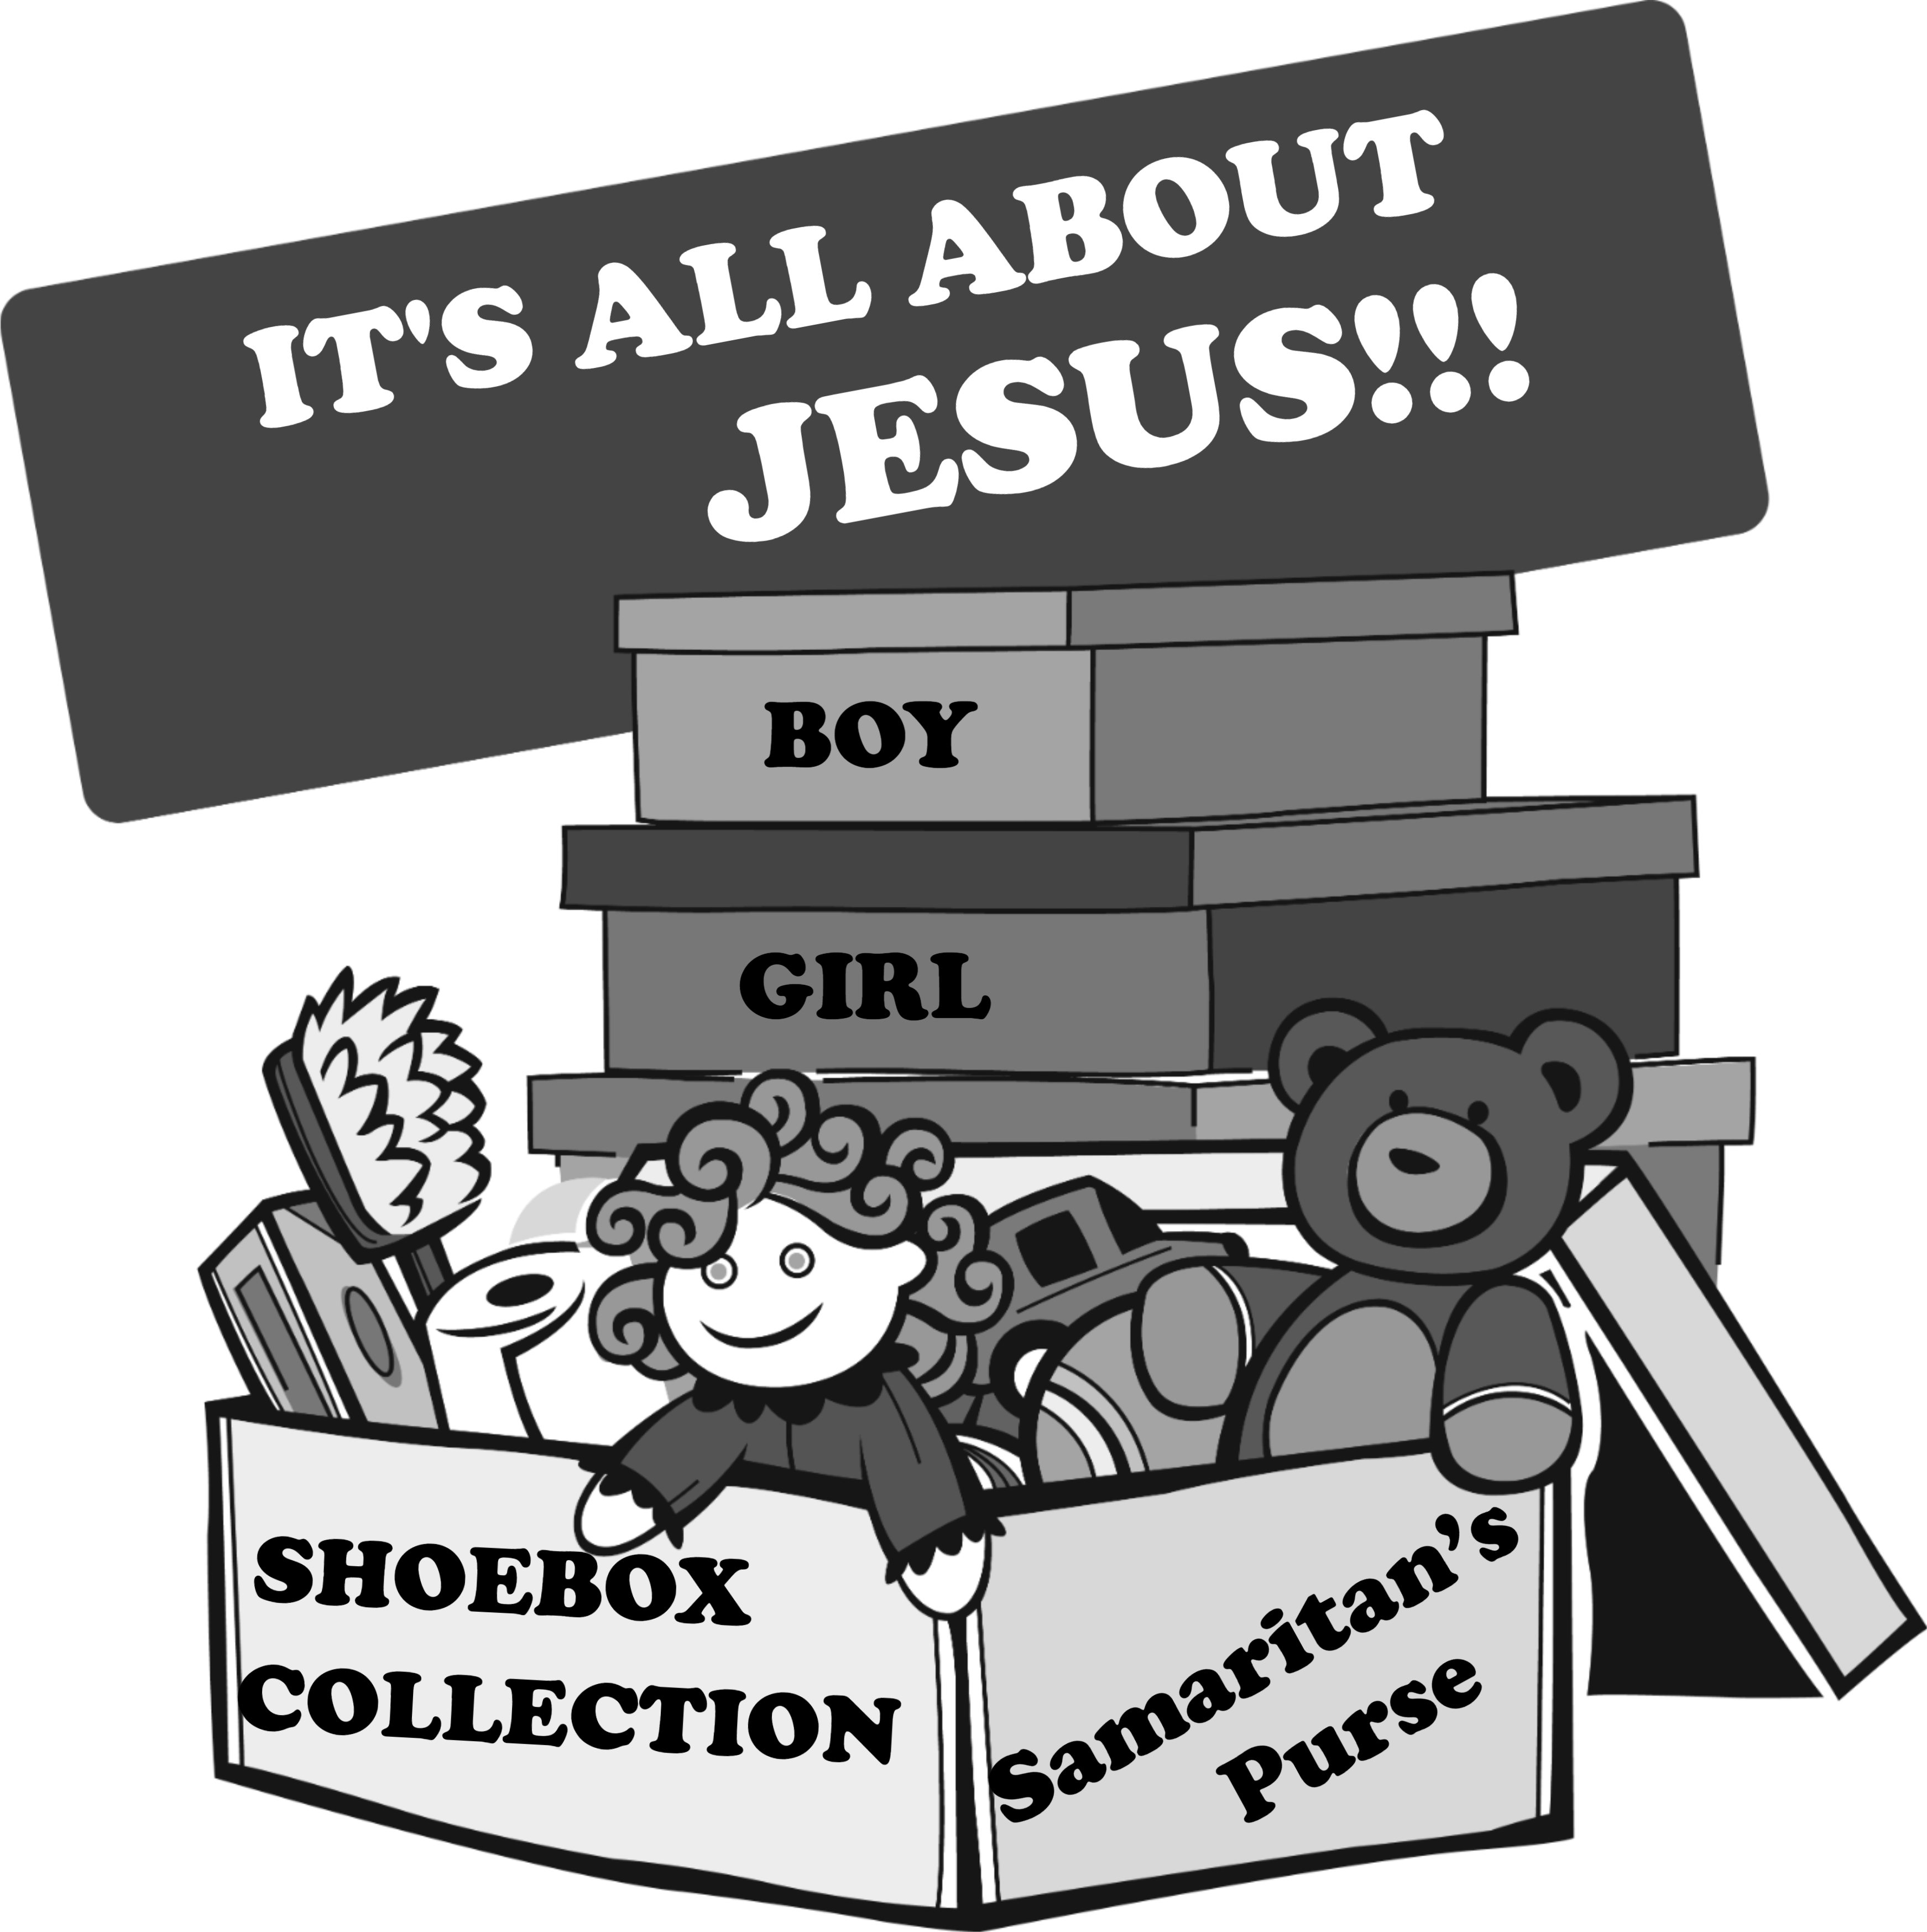
Operation Christmas Child 2026 IT’S ALL ABOUT JESUS!!! Samaritan’s Purse collects gift-filled shoeboxes that individuals, churches, families, and other groups in nearly a dozen countries, prayerfully pack for boys and girls in need around the world. This project delivers not only the joy of what, for many children, is their first gift ever, but also gives them a tangible expression of God’s love. Since the start of the program in 1993, 244 million children in more than 175 countries have received a shoebox. Every box is an opportunity to reach a child with the Gospel of Jesus Christ. As you pack the boxes just remember; “The most important item you can put in your shoebox gift is prayer.” - Franklin Graham. Ask the Lord to use your shoebox as an expression of His love to a child in desperate need.

Boxes are available in the Social Hall and should be packed and returned to the church by October 31st. Please place your packed boxes under the Christmas tree. A donation of $10 per box helps cover collection, processing, and shipping worldwide as well as Gospel materials to accompany each box. However, if you choose to pack a box, it is not mandatory. Monetary donations for this mission of the month can also be made throughout the month of October.



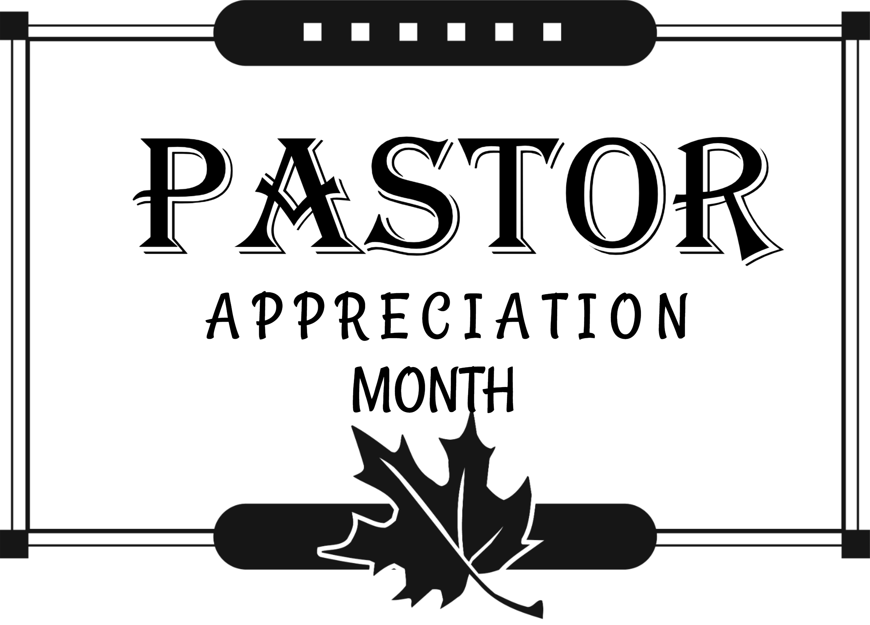
October is typically designated as Pastor Appreciation month. It has been 3 months since Pastor Andrew and Megan have joined with us in ministry at St. Andrew’s. This has been a period of adjustment, change and getting to know one another as we minister together.
Now it’s time to celebrate Pastor Andrew and his commitment to St Andrew’s. The Staff / Parish committee has set aside Sunday, October 25, 2026 as our day to celebrate Pastor Andrew and show our appreciation for his leadership and pastoral ministry with
St. Andrew’s.
There will be a potluck meal, beginning at noon. Ham will be provided, along with rolls, drinks and a cake. Everyone is asked to bring a side or dessert. There will be a basket provided for cards to encourage and wish Pastor Andrew well as he strives to serve at St. Andrew’s. A signup sheet will be available in the Fellowship Hall on Sunday, October 4, so we will have an idea of how many to prepare for.
Let’s make this a day of celebration with Pastor Andrew and a time to encourage him and show our gratitude and thankfulness for him as he leads and guides St Andrew’s into the future in mission and spiritual growth.
So, mark your calendar for Sunday, October 25th at noon, and come join together for a meal and fellowship with Pastor Andrew and Megan.



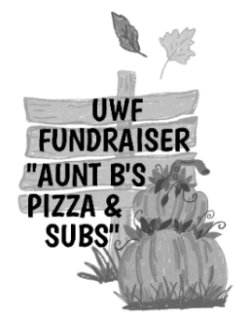
The UWF members will take orders until Oct. 6th.
Please see a member of the UWF to place an order.
Orders & Payments are due October 6th.
Delivery date is Tuesday, October 20th.
Orders can be picked up at the church from 4:00pm to 6:00pm.
As United Women in Faith we are a powerful, fearless force driven by God’s love and united in sisterhood. Proceeds of our fundraising efforts are given to organizations with missions and ministries that focus primarily on women, children and youth.


We offer a safe space for fellowship as well as free pizza, snacks and drinks following the football game until 11:00pm. All Jr. Driver License holders are asked to leave by 10:45pm. This is open to all students in 6th – 12th grade.
See Steve Reitz or sign up on the sheet in the Fellowship Hall to donate snacks, drinks, or your time.
Regular home games are on the following dates:
October 2 / October 9 / October 23
(any additional home playoff games will be announced later)



To order hoagies please contact:
Christy @ 570-985-7240 or Ann @ 570-205-2117.
See the flyer on the bulletin board in Narthex.

Jewel Women's Center
is holding their annual fundraising banquet, Thurs., Oct. 8th at 6:00pm @ LCBC.
The cost is $20.
St. Andrew's is again this year, looking to fill a table at the banquet. The meal will be provided by Across the Valley.
Mary Ellen Klebe will be hosting a table of 8. At this time, we have 3 people and looking for 5 more to fill the table! Please see Mary Ellen Klebe for more information and how to register. We will hear an amazing story of how God works through Jewel to save the lives of the unborn in Schuylkill County! You won't want to miss this amazing evening!!


Happy 99th Birthday – Tillie Wolfgang
10/20/26
Happy 90th Birthday – Jean Kehler
10/23/26
Happy 90th Birthday – Dora Mae Wagner 10/29/26
May God Bless you all on your special days!


Chaplain Glenn R. Scheib
95-957 Wikao Street
Mililani, HI 96789

Rev. David Wagner
7517 S. 950 W-92
North Manchester, IN 46962

Nursing Home – Group Home
Assisted Living – Rehab (family)

Randy Snyder
Vanessa Weaver

Schuylkill Manor
1000 Schuylkill Manor Road
Pottsville PA 17901
Tillie Wolfgang

Edenbrook Greenwood Hill
420 Pulaski Drive
Pottsville, PA 17901
Gail Bowman

Providence Place, Pine Grove
24 Hikes Hollow Road
Pine Grove, PA 17963
Marilyn Herb, Doris Lettich, Dolores Stutzman, Marlene Updegrave
Larry Wetzel

Cedar Haven Healthcare Center
590 S. 5th Avenue
Lebanon, PA 17042
Sandy Bordlemay

Capital Rehabilitation
4000 Linglestown Road
Harrisburg, PA 17112
Denise Schlegel

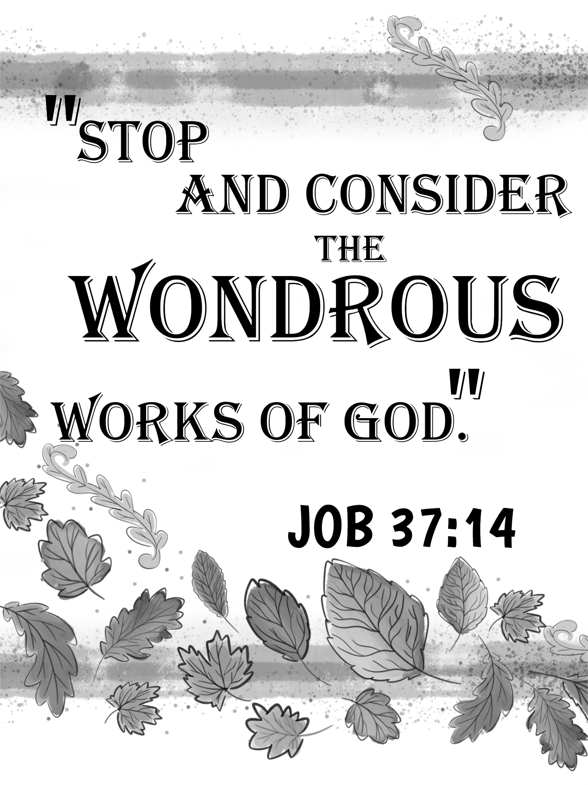


OCTOBER 2026
Sun | Mon | Tue | Wed | Thu | Fri |  | Sat
Let us not become weary in doing good, for at the proper time we will reap a harvest if we do not give up. Galatians 6:9 |  |  |  | 1 | 2  5th Quarter |  | 3
4  World Wide Communion | 5  Watch bulletins for Men’s Chorus & Chancel Choir | 6  UWF Pizza & Sub orders & money due TODAY | 7 | 8  10:00am – Sr. Citizens  6:00pm – Jewel Banquet @ LCBC | 9  5th Quarter |  | 10
11 | 12 | 13  6:30pm – Trustees  7:30pm – Ad Board | 14 | 15 | 16 |  | 17
18 | 19 | 20  1:00pm - UWF  4:00-6:00pm Subs/Pizza Pickup | 21 | 22  10:00am – Sr. Citizens | 23  5th Quarter |  | 24
25  12:00 Noon – Pastor Appreciation Celebration | 26 | 27 | 28 | 29 | 30 | 31
NOTES: 


St. Andrew’s U.M. Church
PO Box 221
Valley View, PA 17983
*Address Service Requested

ST. ANDREW’S U.M. CHURCH

“S.A.M.”

OCTOBER
2026

