NOVEMBER 2025
St. Andrew’s
Messenger
St. Andrew’s United Methodist Church “growing in passion for God, showing compassion to all”
Our Mission: “To make disciples of Jesus Christ, who are growing in passion for God and showing compassion to all, by sharing God’s REPAIRing Love.”
Our Vision: making disciples through:
Radical hospitality
Extravagant generosity
Passionate worship
Authentic witness
Intentional faith development
Risk taking mission

Pastor: Suzanne Elliott
570-682-3508 (Office)
717-253-1263 (Cell)
e-mail: selliott@susumc.org

Office Hours and Information:
Secretary – Karen Koppenhaver
Tuesday and Thursday:
10:00 am - 12:00 pm
Phone – 570-682-3508
office@standrewsvalleyview.org

Newsletter Articles:
E-mail to the address below:
office@standrewsvalleyview.org

Prayer Chain Contact:
Carole Hepler – 570-682-3301
chelper@comcast.net

St. Andrew’s Web site: www.standrewsvalleyview.org



"We thank you for this day and for its blessings. We thank you for this food, bless it to our use and us to your service. In Jesus' name we pray, Amen." Rev. Henry Miller

This prayer is the one that my Grandpa Henry used to pray before every meal. Over many years and meals together, I memorized this prayer. It's the "grown up" prayer that I pray now with my family when we gather around the table. We taught our young children a version of "God is great, God is good...." which we still use occasionally. But when I sit at a table to pray for a meal these days, this is what comes to mind.

This is the season of thanksgiving. I know that we should be thankful all year long! But, there's something special about the trees changing colors, the air getting cooler, and the promise of turkey and stuffing on the table on the fourth Thursday. This season calls me to be thankful.

What am I thankful for - beyond the obvious blessings of health, family, daily food, warm house, and Jesus Christ? I'm thankful for my grandfather and his prayer. I'm thankful for warm, comfy sweaters. I'm thankful for tasty new recipes. I'm thankful for football games and school plays. I'm thankful for so many little things that I daily take for granted.

What are you thankful for? I hope that you will take some time in this season of thanksgiving to reflect on the many blessings in your life. Even if life is hard for you, right now, there is something or someone blessing your life. "We thank you for this day and for its blessings...."

A very Happy Thanksgiving to you!

~Pastor Suzanne

NOVEMBER
MISSION OF THE MONTH

Archelet Duverne is the Founder and CEO of H2ope Ministries™, a Christ-centered nonprofit dedicated to ending both physical and spiritual poverty in vulnerable Haitian communities. With over 20 years of experience in nonprofit leadership, Archelet has served in key roles such as executive director, program coordinator, policy and advocacy officer for organizations including Tearfund, Food for the Hungry, and Passion Rescue Mission. His work has focused on sustainable development, ethical leadership, and empowering families through faith-driven service. Under his guidance, H2ope Ministries™ has built over 350 water reservoirs, providing clean, reliable water to families—freeing children and women from the burden of long walks and daily struggles just to collect water for household needs.
Archelet believes that every child deserves dignity, opportunity, and love—just as he would want for his daughter. This belief fuels his commitment to nurturing not only the physical needs of communities but also their spiritual and educational growth.
Through H2ope’s “From Buckets to Books” initiative, Archelet provides spiritual guidance to children. Beginning this school year, he has launched a new journey with H2ope Ministries™ to offer free education to children whose families cannot afford tuition and have been left out of school. These programs help children grow in knowledge, character, and faith—preparing them to become productive servants of God. Archelet humbly seeks your prayers for this ministry and welcomes any support that can help make a lasting difference in this godly mission for the children of Haiti.
You may place your contributions in the "mission can" located next to the offering plates in the Sanctuary OR you can note your donation on your regular offering envelope. Make any checks payable to St. Andrew's UMC.


Here are three ways to give beyond your regular church offerings this month:

1. United Women in Faith "Thank Offering"
This annual offering supports the work of the United Women in Faith at the national and international levels. Special envelopes for this offering will be in your bulletin on November 2 and on the table in the entryway on November 8. Make checks payable to United Methodist Women.

2. Mission of the Month - H2ope Ministries
You can contribute to this mission during the entire month of November (see article). Use the "mission can" located next to the offering plates in the Sanctuary OR you can note your donation on your regular offering envelope. Make any checks payable to St. Andrew's UMC.

3. Thanksgiving Day Meal food donations
Several food donations will be needed for our annual Thanksgiving Meal. A sign-up sheet will be available in the Social Hall. Watch the bulletin for details as the event gets closer.


THE UPPER ROOM is a daily devotional booklet to guide your study of the scriptures, pray, focus on a thought, and have inspirational readings.
The November/December issue is dark blue with vivid colors.
Does the colorful image challenge your vision of the Bible story (Luke 1:26-38)?
November 30 is the start of the Advent season. May we join together in preparation for the Christ child.
Books are available at each entrance door.


WHERE: Lykens United Methodist Church
WHEN: Saturday, November 1
TIME: 1:00pm Business Meeting
2:00pm Worship
This year's Church Conference will be a large community event! The ten churches of our cluster will gather at 1:00 for our business meetings. This year Pastor Suzanne will preside at St. Andrew's Church Conference. We will then be joined at 2:00 for worship by members of six churches from the Millersburg and Halifax areas. When worship is concluded, those churches will have their business meetings. All church members are welcome to attend with voice and vote.


Ignite Children’s Ministry
Preschool (with an adult) – 5th Grade
RSVP attendance to standrewsvalleyview221@gmail.com


Building Our Faith
November 5th, 12th, 19th 6:00-7:30pm
We will do hands-on woodworking projects and learn how our lives are BUILT on Jesus Christ and we are MADE for a purpose


The Gift of Christmas
Friday, December 12th 5:00-7:30pm
Join us as we celebrate Jesus – the greatest gift ever given!


We remember, with thanksgiving, the lives of these persons who have died this past year. We thank God for their lives among us and celebrate their healing and wholeness in heaven.
Barbara A. Miller, November 16, 2024
Ann Louise Schiliro, November 24, 2024
Bruce C. Miller, December 17, 2024
Marie A. Clark, March 13, 2025
Constance L. Scheib, March 29, 2025
Jo Ann Shade, April 4, 2025
Lester E. Donmoyer, April 13, 2025
Richard U. Walker, Sr., May 3, 2025
Geraldine D. Hepler, May 4, 2025
Carolyn R. Miller, August 30, 2025
The list includes church members and those to whom Pastor Suzanne extended the ministry of the church by officiating at the funeral.

Church Treasurer to Retire December 30
Church leadership is looking for a new Church Treasurer beginning January 1. This is a volunteer position. If anyone believes they have the time and gifts to fill this position, or wants to know more, please see Pastor Suzanne or Mary Ellen Krammes. Let's all be in prayer for God to raise up the next person for this important position.
APPLE FESTIVAL REPORT
St. Andrew’s had a beautiful day for the Apple Festival and it was enjoyed by all there.
We sold out of most everything this year! The profit this year was $4,321.53 which was designated for the People Fund. Without everyone working together, this would not be possible. All is greatly appreciated.

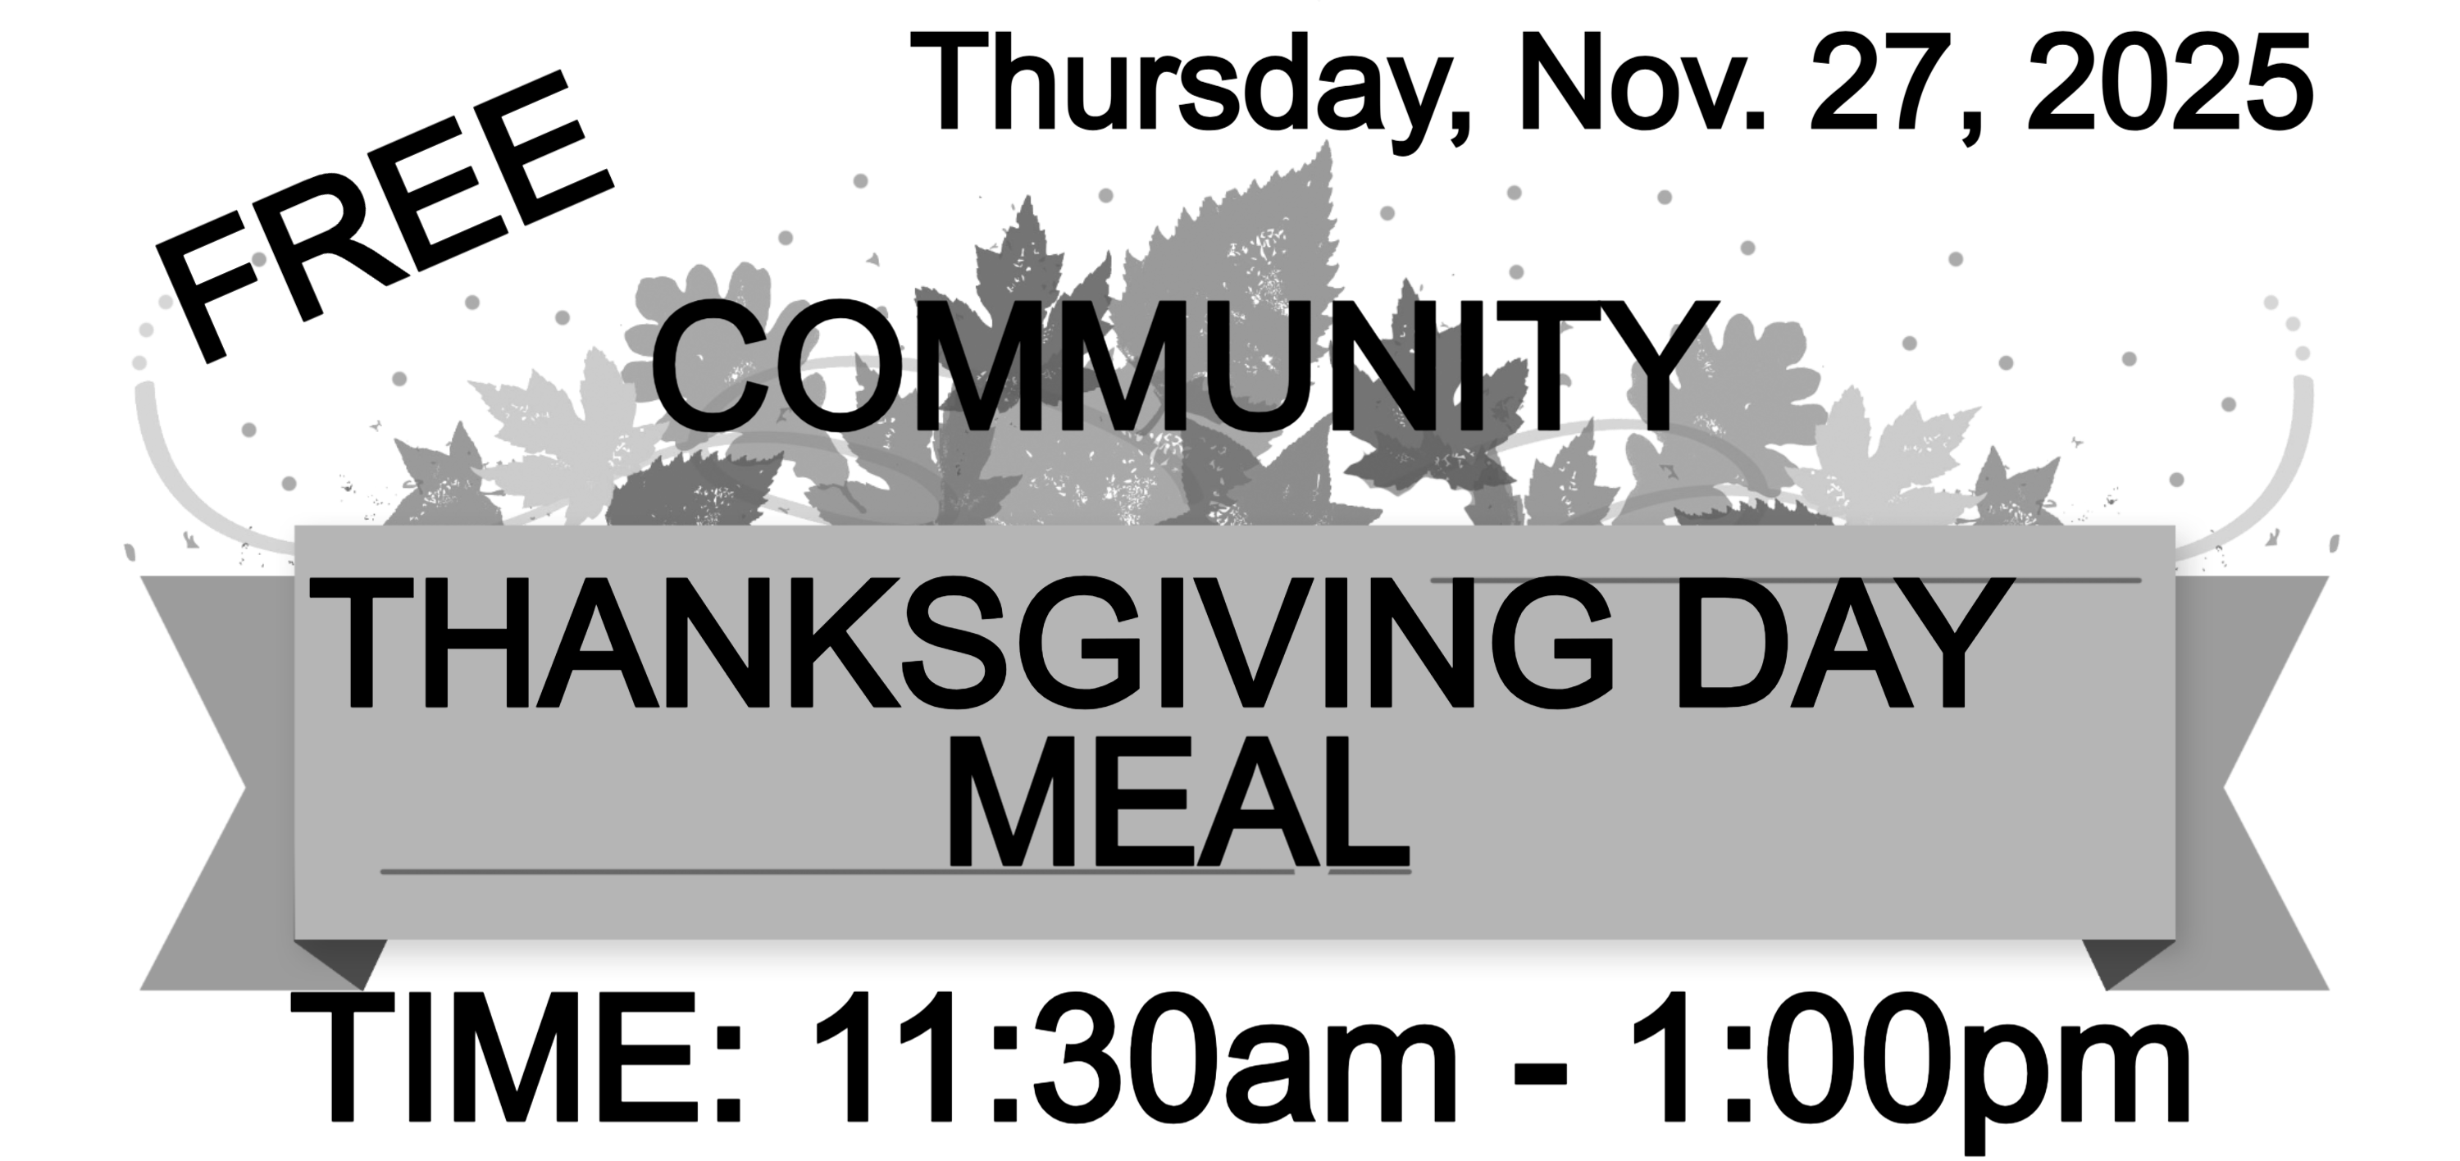
We will be hosting our 9th Thanksgiving Day Meal for all who would like to join us for a “full spread” meal. We have been blessed each year with your support and donations, enabling us to do this.
Each year some person/family/group has been blessed because of gracious and generous monetary donations received the day of the meal.
There is no charge for the meal. We will serve eat-in or take-out meals. We only ask that you contact the church office at (570) 682-3508 to register, for either eat-in or take-out. We would like to have a count by November 23rd. Walk-ins are welcome Thanksgiving Day.
Help is needed on Wednesday, the day before, for setting up the fellowship hall, as well as prepping food. Thanksgiving Day, we will need help with cooking, serving, and clean-up. Pies, cakes, pumpkin rolls, or cobblers will be needed, and perhaps some other meal items (Watch bulletins for any items needed).
Donation / Volunteer sheets will be in the Fellowship Hall. Any youth interested with helping will receive Community Service hours. If there are any questions, please contact Karen at 570-590-7330.

Pine Creek Christmas Outreach Discontinued
Due to the declining numbers of children and the amount of help needed for the project, Pine Creek Outreach has decided to discontinue their Christmas gift ministry. That means there will NOT be a little tree in the Sanctuary with envelopes to choose. Thank you to each of you that took envelopes and shopped for gifts in years past!

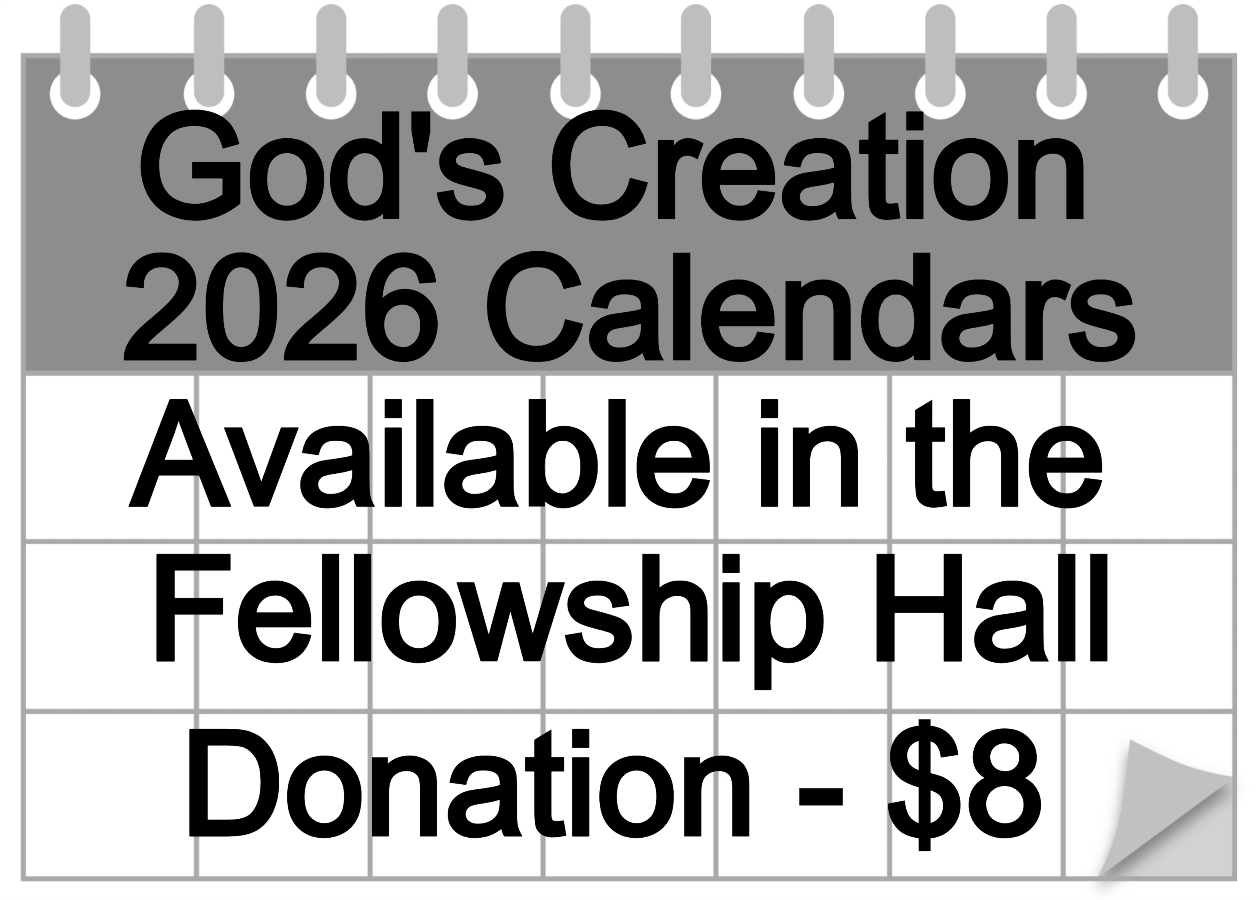
Calendar donations benefit the Youth Group.

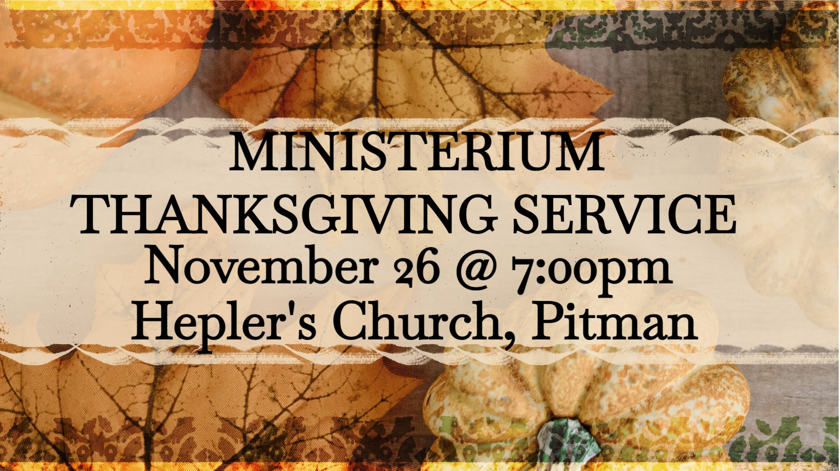


Advent begins Sunday, November 30
Advent is the beginning of a new year of waiting, but it is an active and watchful waiting. It is tapping into the world's longing for redemption, salvation, and transformation. All of earth is waiting for this fulfillment. In worship, we can see the signs of the nearness of Emmanuel, God with us. This Advent we will focus on what we should do as we wait for God. We wait for the Christmas celebration. We wait for Christ to come again.


Sunday, November 30 7:00 pm
Join St. Andrew's Chancel Choir and other area choirs for the annual hymn sing to kick off the Advent season hosted by St. John's UMC, Hegins


Dear Church,
Thank you so very much for choosing to volunteer at the Lighthouse and for making your recent donation of cleaning products (taken along when volunteering). We appreciate your partnership as we support our communities.
Sincerely, Valley Volunteers.

SR. CITIZENS NEWS
The Senior Citizens will only meet once in November, Thursday, November 13th.

December 11th is the Christmas Dinner at 12:00 noon. This will be the only meeting in December.


Chaplain Glenn R. Scheib
95-957 Wikao Street
Mililani, HI 96789

Rev. David Wagner
7517 S. 950 W-92
North Manchester, IN 46962

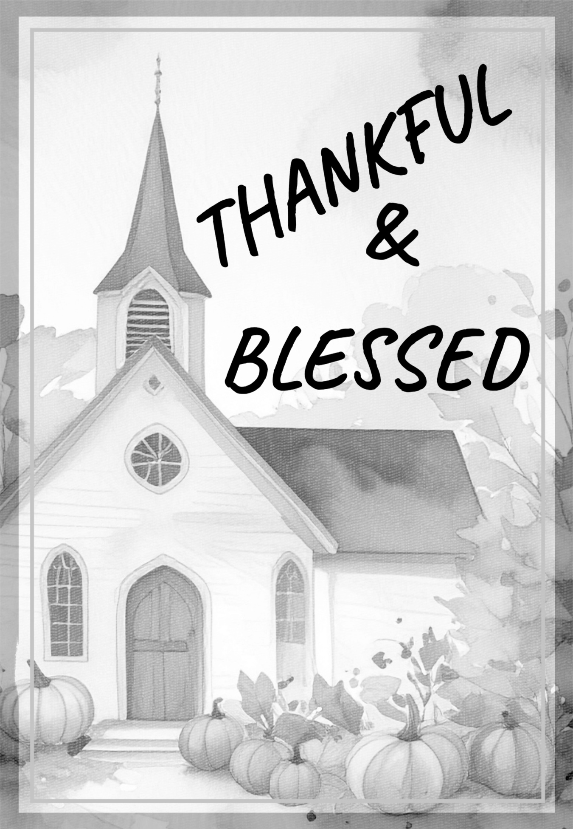

Nursing Home – Group Home
Assisted Living – Rehab (family)

Randy Snyder
Vanessa Weaver

Schuylkill Manor
1000 Schuylkill Manor Road
Pottsville PA 17901
Tillie Wolfgang

Edenbrook Greenwood Hill
420 Pulaski Drive
Pottsville, PA 17901
Gail Bowman

Providence Place, Pine Grove
24 Hikes Hollow Road
Pine Grove, PA 17963
Ella Artz, Marilyn Herb, Dolores Stutzman, Larry Wetzel

Tremont Health & Rehab Center
44 Donaldson Road
Tremont, PA 17981
Roger Schwalm

Cedar Haven Healthcare Center
590 S. 5th Avenue
Lebanon, PA 17042
Sandy Bordlemay

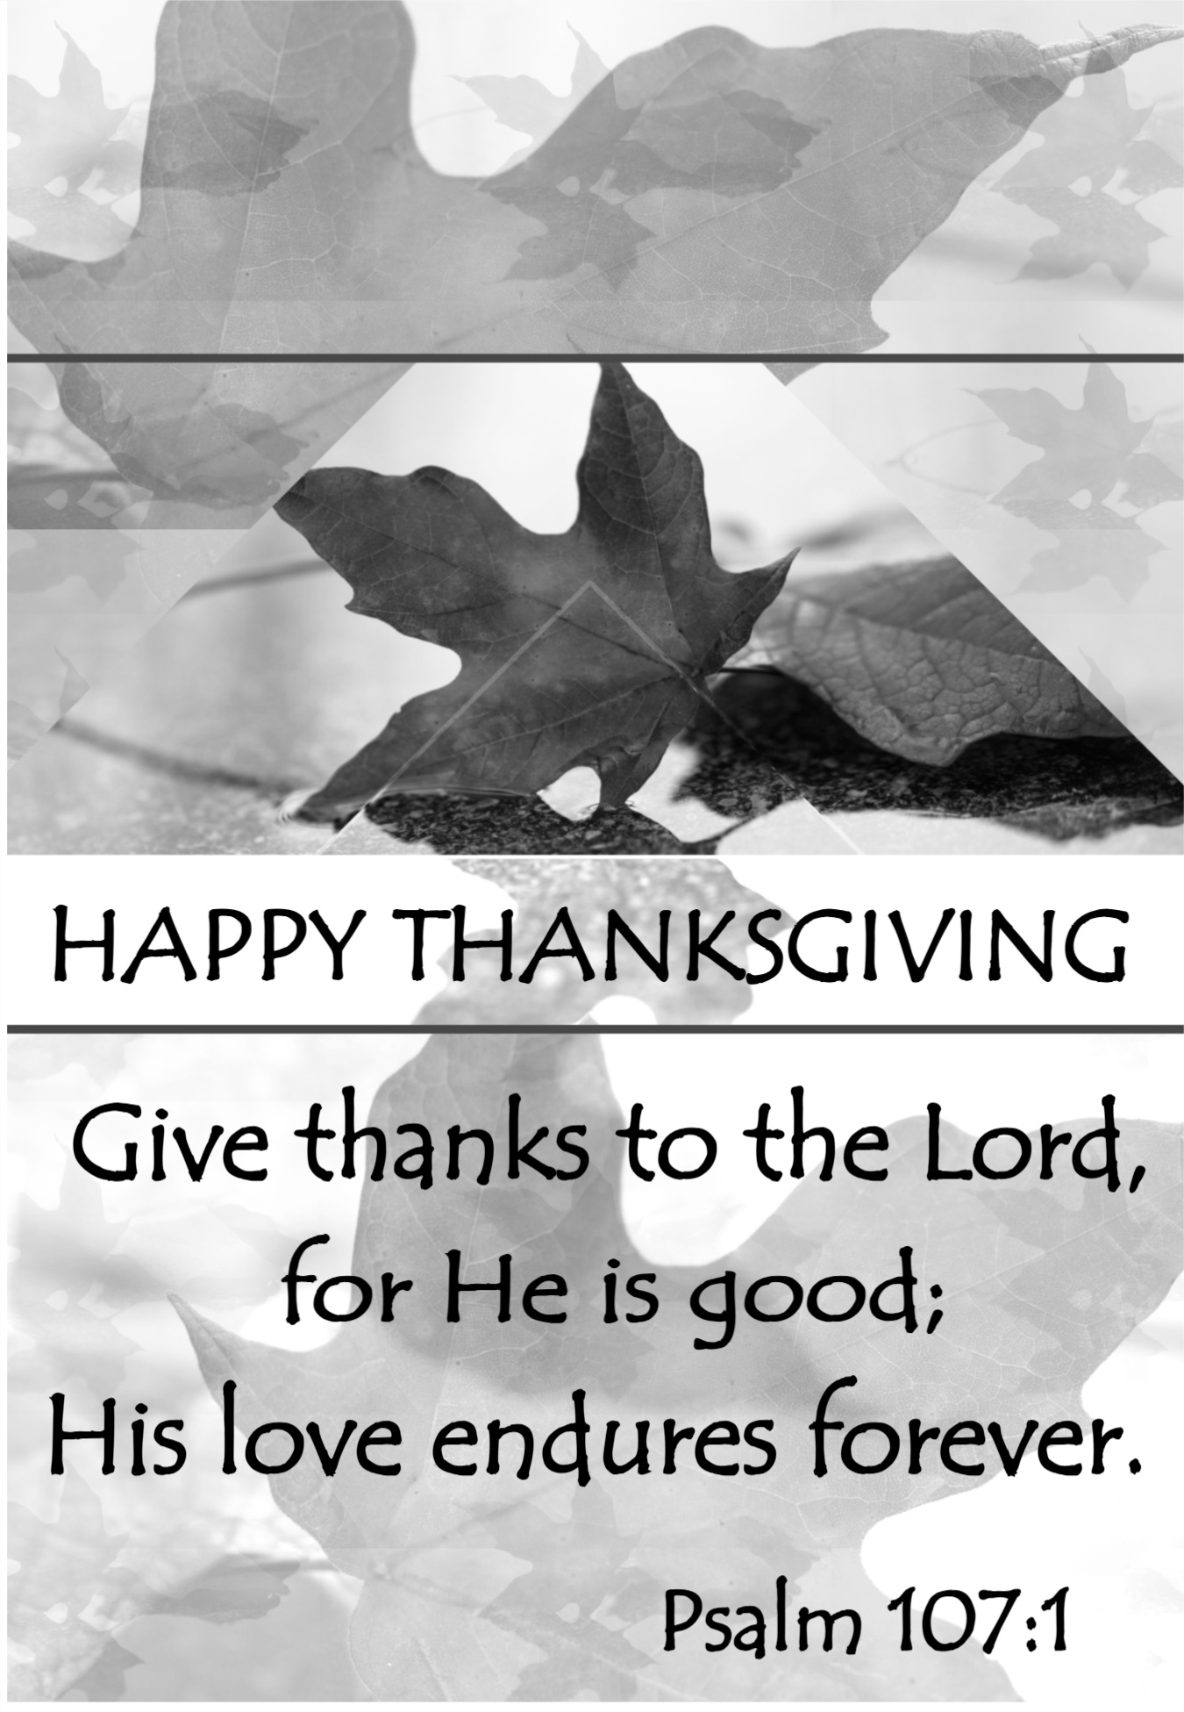


NOVEMBER 2025
Sun | Mon | Tue | Wed | Thu | Fri | Sat
Psalm 100:4  Enter his gates with thanksgiving and his courts with praise; give thanks to him and praise his name. |  |  |  |  |  | 1  1:00pm – Church Conference, Lykens
2  All Saints Day | 3  7:00pm – Chancel Choir | 4 | 5  6:00pm - 7:30pm - IGNITE | 6 | 7 | 8
9  UWF  Thank Offering Sunday | 10  6:15pm – Men’s Chorus  7:00pm – Chancel Choir | 11  12 Noon – Ministerium Luncheon  6:30pm – Trustees  7:30pm – Ad. Board | 12  6:00pm - 7:30pm - IGNITE | 13  10:00am – Sr. Citizens | 14  Fellowship Hall Kitchen – H.S. Students | 15
16 | 17 | 18  1:00pm – UWIF | 19  6:00pm - 7:30pm - IGNITE | 20 | 21 | 22
23 | 24  6:15pm – Men’s Chorus  7:00pm – Chancel Choir | 25  10:00am – 12:00pm Office Hours | 26  Thanksgiving Meal prep/setup  7:00pm – Ministerium Thanksgiving Service | 27 HAPPY  THANKSGIVING  11:30am – 1:00pm Thanksgiving Meal  OFFICE CLOSED | 28  *OFFICE HOURS 8:00am – 10:00am | 29
30  Advent Begins | 31  6:15pm – Men’s Chorus  7:00pm – Chancel Choir | 
Notes:
SUNDAY WORSHIP – 9:00 am SUNDAY SCHOOL – 10:30 am
OFFICE HOURS – Tuesday & Thursday – 10:00 am – 12:00 pm (See times on calendar)
BULLETIN DEADLINE – Thursday – 9:00 am
NEWSLETTER DEADLINE – Third Friday of Month
* Watch bulletin for changes.

St. Andrew’s U.M. Church
PO Box 221
Valley View, PA 17983
*Address Service Requested

ST. ANDREW’S U.M. CHURCH
“S.A.M.”



NOVEMBER 2025

