OCTOBER 2025 
St. Andrew’s
Messenger
St. Andrew’s United Methodist Church “growing in passion for God, showing compassion to all”
Our Mission: “To make disciples of Jesus Christ, who are growing in passion for God and showing compassion to all, by sharing God’s REPAIRing Love.”
Our Vision: making disciples through:
Radical hospitality
Extravagant generosity
Passionate worship
Authentic witness
Intentional faith development
Risk taking mission

Pastor: Suzanne Elliott
570-682-3508 (Office)
717-253-1263 (Cell)
e-mail: selliott@susumc.org

Office Hours and Information:
Secretary – Karen Koppenhaver
Tuesday and Thursday:
10:00 am - 12:00 pm
Phone – 570-682-3508
office@standrewsvalleyview.org

Newsletter Articles:
E-mail to the address below:
office@standrewsvalleyview.org

Prayer Chain Contact:
Carole Hepler – 570-682-3301
chelper@comcast.net

St. Andrew’s Web site: www.standrewsvalleyview.org


"Then Peter came up to Jesus and asked, "How many times shall I forgive my brother or sister who sins against me? Up to seven times?"
Matthew 18:21

I'm sure most of you know how Jesus answered Peter's question. Forgiveness is a cornerstone of the Christian faith. We believe that God forgives us, through the grace of Jesus Christ. We are then to forgive others as we have been forgiven. Jesus has strong words to say about forgiveness! Read Matthew 18:21-35. Jesus follows up Peter's question with the Parable of the Unmerciful Servant.
It is not easy to forgive others when they hurt you. The bigger the hurt, the bigger the barrier to forgiveness. It's the human way to want revenge or to watch our enemies suffer. However, Christians are called to be different. We follow the example and teaching of Jesus. Remember, even as he was dying on the cross, Jesus extended forgiveness to those who tortured and crucified him.
Hundreds of thousands of people recently heard a courageous message about forgiveness from Charlie Kirk's widow, Erika. I admire her willingness to extend forgiveness in a time of deep grief. Another powerful example of forgiveness happened after the Nickel Mines Amish School shooting in 2006. This event led to a book and a movie which continued to inspire more people to forgive others.
If we choose to claim the name "Christian" then we need to be following in the footsteps of Jesus Christ. First, we need to know what Jesus taught and the example he set forth. Second, we need to do our best to be like him. This is not always popular. It is not the "way of the world." Christians are meant to shine a different light!

Shine on!

~Pastor Suzanne

OCTOBER
MISSION OF THE MONTH
OPERATION CHRISTMAS CHILD

The October mission of the month is Operation Christmas Child, a project of Samaritan’s Purse. This project delivers not only the joy of what, for many children, is their first gift ever, but also gives them a tangible expression of God’s love. Every box is an opportunity to reach a child with the Gospel of Jesus Christ.
Boxes will be available in the Fellowship Hall and should be packed and returned to the church by October 31st. A donation of $10 per box is critical to cover shipping and other project costs, however, if you choose to pack a box it is not mandatory. Monetary donations for this mission can also be made throughout the month of October.

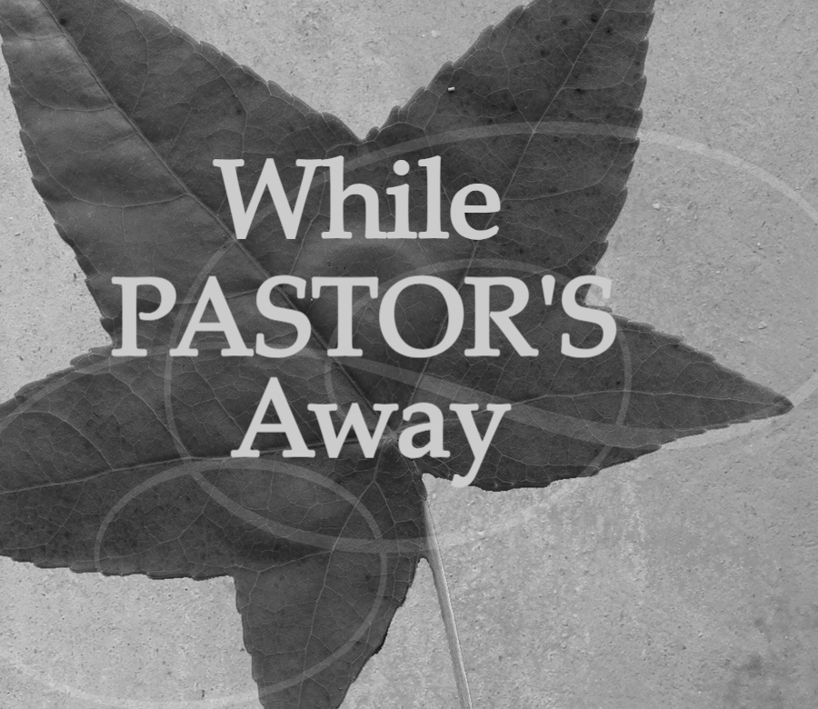
Pastor Suzanne will be on vacation
October 1-7. For all pastoral needs
Rev. Ray Holland/570-452-0050 will be on call.


Sunday, October 5 we will observe World Communion Sunday with Rev. Dr. Kathleen (Kathy) Kind preaching and presiding over Communion. Kathy serves our Conference as the Director of Connectional Ministries. She's also been a friend and colleague of Pastor Suzanne's for 25 years. If you attended the 2024 Church Conference in Lykens, Kathy
conducted the business for our church. Welcome to St. Andrew's Kathy!
All students, grades 5th – 12th are invited to 5th Quarter after all home football games. DATES: Oct. 3 / Oct. 10


UWF HOAGIE AND PIZZA FUNDRAISER
The UWF will be hosting a hoagie & pizza sale October 22nd.
HOAGIES: 8 inch - $6.50 each - Regular, Turkey & Cheese, Ham & Cheese, or Italian
PIZZAS: 12”x17” – Cheese - $16 / 12”x17”
Pepperoni - $17
Orders may be placed with any UWF member or a signup sheet in the Fellowship Hall or Call Sandy Renninger at 717-639-4761. All orders must be in by Sunday, October 12th. Payment is due at time of pickup, Wednesday, October 22, from 4:30pm – 6:00pm at church.


WHAT: Tri Valley Area Youth Night
WHEN: October 11th / 4:00-7:00pm
WHERE: St. John's UMC, Hegins
St. John's UMC Women in Faith will sponsor a youth night for area youth groups. Dress up in your favorite Halloween costume. Prizes will be awarded.


Community Service Night
October 29 / 5:00-7:30pm
Grades 9-12
We will once again be offering dinner and two hours of community service credit. Thanks to your generosity during the month of July, we have supplies for projects and money to purchase additional items. We hope to build relationships with our area youth and bless Mission Central and/or Caitlin's Smiles as well.

* A heartfelt “Thank You” to all who helped in any way for the Apple Festival. To all who baked dumplings, pies, desserts, made soups, helped with applesauce & butter, helped the day of in so many various ways and to those who supported us by attending or placing orders! A full report will be included in the November Newsletter. We can only be successful when we pray and work together for the glory of God!


* Thank You for your generous support of our August Mission of the Month - Backpacks for Schuylkill County Children and Youth. We collected 24 backpacks and $405.00. Due to lack of storage at the county office, we did not use the donated money to purchase materials to make additional backpacks this year. Instead, we were asked to help sponsor families (that the county works with) to provide gifts for children at Christmas. Your Administrative Board was happy to support this request!


* Thank You to our Volunteers!
Two groups volunteered at Valley Lighthouse in Lykens in September. On Friday, the 19th, four people helped to stock shelves with food supplies. On Monday, the 22nd, eight people helped sort books and movies and transition clothes from summer to winter. The Valley Lighthouse Sharing Center is open from 10 to 3 Monday through Thursday. Much like a thrift store, there are clothes, shoes, household goods, food items, and much more. However, nothing is priced - you just give a donation. Anyone can come and "shop." They also have monthly give-a-ways of food, decorations, etc. Anyone can attend these too. All they ask for is an ID. Everything they give away is donated, mostly from large corporations like WalMart. Massers provides a pallet of potatoes every month too! They pay their bills through financial donations, fundraisers, and renting their building to outside groups. They will be happy for our donations! It's an amazing place. You should stop and see it! Thank you for your generous support.


*Thank You for supporting Amy Hautle in her ministry with CEF and allowing her and Shelley to share in worship with St. Andrew’s. CEF reached 406 children throughout summer camps/ministries. Shelley Hikes


WHERE: Lykens United Methodist Church
WHEN: Saturday, November 1
TIME: 1:00pm Business Meeting
2:00pm Worship
This year's Church Conference will be a large community event! The ten churches of our cluster will gather at 1:00 for our business meetings. This year Pastor Suzanne will preside at St. Andrew's Church Conference. We will then be joined at 2:00 for worship by members of six churches from the Millersburg and Halifax areas. When worship is concluded, those churches will have their business meetings. All church members are welcome to attend with voice and vote.


Congratulations to Pastor Suzanne and Rick's daughter Emily, who will marry Ryan Sanders on Saturday, October 4 in Spring Grove, PA


Steve Klinger is asking your help if you see any decaying trees hanging over any state highways in our area. Please report this to Kevin Krull, PENNDOT Supervisor, 570-385-7816. Please make sure you give the location of any trees seen.

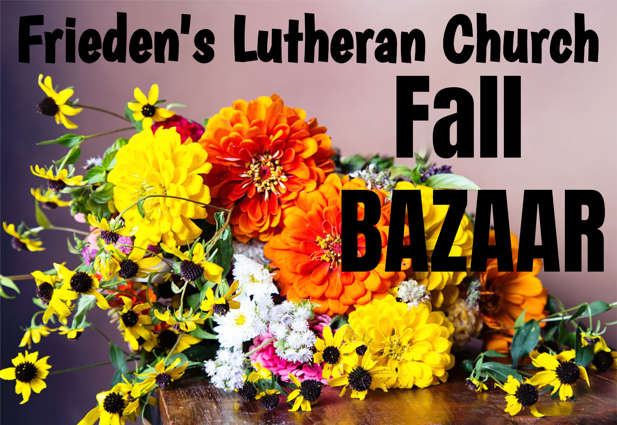
Saturday, October 4th – 9:00 – 11:00am
Hoagies, Soups, Baked Goods
Pre-order Hoagies! They rarely have extra!
Call Jean Morris 570-617-6529 for ordering or questions.


Jewel’s Banquet – October 23 @ 6:00pm – Mountainside Community Center. Deadline to register for the banquet is Oct 16, cost is $20, Pastors and spouses are complimentary. We are working to fill a table of 8. More info to follow in bulletins. See Mary Ellen Klebe if there are any questions.


Nursing Home – Group Home
Assisted Living – Rehab (family)

Randy Snyder
Vanessa Weaver

Schuylkill Manor
1000 Schuylkill Manor Road
Pottsville PA 17901
Tillie Wolfgang

Edenbrook Greenwood Hill
420 Pulaski Drive
Pottsville, PA 17901
Gail Bowman

Providence Place, Pine Grove
24 Hikes Hollow Road
Pine Grove, PA 17963
Ella Artz, Marilyn Herb, Dolores Stutzman, Larry Wetzel

Tremont Health & Rehab Center
44 Donaldson Road
Tremont, PA 17981
Roger Schwalm

Cedar Haven Healthcare Center
590 S. 5th Avenue
Lebanon, PA 17042
Sandy Bordlemay



Vicki Harman Lois Kimmel
Rodney Klinger Martha Lahr
Carolyn Miller Peggy
Mary Steckle



October 2025
Sun | Mon | Tue | Wed | Thu | Fri | Sat
“Peacemakers who sow in peace reap a harvest of righteousness.”  James 3:18 |  |  | 1  Pastor - Vacation | 2  Pastor - Vacation | 3  5th Quarter  Pastor - Vacation | 4  Pastor - Vacation
5  Pastor - Vacation | 6  6:15pm – Men’s Chorus  7:00pm – Chancel  Choir  Pastor - Vacation | 7  Pastor - Vacation | 8  7:00pm – IGNITE Meeting | 9  10:00am – Sr. Citizens  7:00pm – Lay Leadership (Nominations Committee) | 10  5th Quarter | 11  4:00-7:00pm – St. John’s UMC Youth Night  Fellowship Hall Rental
12  UWF - All Sub/Pizza orders Due TODAY | 13  6:15pm – Men’s Chorus  7:00pm – Chancel Choir | 14  6:30pm – Trustees  7:30pm – Ad. Board | 15 | 16 | 17 | 18  Fellowship Hall Rental
19 | 20 | 21  1:00pm – UWF | 22  4:30-6:00pm - UWF – SUB/PIZZA  PICK UP | 23  10:00am – Sr. Citizens  6:00pm – Jewel Banquet | 24 | 25  Fellowship Hall Rental
26 | 27  6:15pm – Men’s Chorus  7:00pm – Chancel Choir | 28 | 29  5:00pm – 7:30pm Youth Community Service | 30 | 31 | 

Notes:

SUNDAY WORSHIP – 9:00 am SUNDAY SCHOOL – 10:30 am
OFFICE HOURS – Tuesday & Thursday – 10:00 am – 12:00 pm
BULLETIN DEADLINE – Thursday – 9:00 am
NEWSLETTER DEADLINE – Third Friday of Month
* Watch bulletin for changes/information

St. Andrew’s U.M. Church
PO Box 221
Valley View, PA 17983
*Address Service Requested

ST. ANDREW’S U.M. CHURCH
“S.A.M.”



OCTOBER 2025

