SEPTEMBER 2025
St. Andrew’s
Messenger
St. Andrew’s United Methodist Church “growing in passion for God, showing compassion to all”
Our Mission: “To make disciples of Jesus Christ, who are growing in passion for God and showing compassion to all, by sharing God’s REPAIRing Love.”
Our Vision: making disciples through:
Radical hospitality
Extravagant generosity
Passionate worship
Authentic witness
Intentional faith development
Risk taking mission

Pastor: Suzanne Elliott
570-682-3508 (Office)
717-253-1263 (Cell)
e-mail: selliott@susumc.org

Office Hours and Information:
Secretary – Karen Koppenhaver
Tuesday and Thursday:
10:00 am - 12:00 pm
Phone – 570-682-3508
office@standrewsvalleyview.org

Newsletter Articles:
E-mail to the address below:
office@standrewsvalleyview.org

Prayer Chain Contact:
Carole Hepler – 570-682-3301
chelper@comcast.net

St. Andrew’s Web site: www.standrewsvalleyview.org



Our worship theme for September is "wisdom." We will explore what makes a wise and faithful Christian. Those of us who have.... lived for a while.... know that sometimes we learn things the hard way. Our parents probably gave us good advice but somehow, we still had to figure things out for ourselves. Perhaps you've been a wise parent and bit your tongue instead of saying to your child "I told you so!" We might wish that we learned all we needed to know in life the easy way. This is not how life works. It's not how faith works either.

In Genesis 22, Jacob wrestles with an angel. In the morning, when he prevails, he is profoundly changed. This change is signified by the giving of a new name - Israel. This became not only Jacob's new name but the name of his descendants. It's worth noting that God's very people who are chosen, loved, and guided, are named Israel, a name won through struggle.

The apostle Paul urged his followers to become mature in their faith. In Colossians 1:28 he says, "He is the one we proclaim, admonishing and teaching everyone with all wisdom, so that we may present everyone fully mature in Christ." We should all be growing in our faith through learning, prayer, service, AND struggle. Let's grow together in wisdom so that we can be the most faithful representatives of Jesus Christ we can be.

I look forward to worshipping with you!
~Pastor Suzanne


SEPTEMBER
MISSION OF THE MONTH

The mission chosen for this month is
The Valley Lighthouse

Their mission is to make a difference one family at a time by offering life skills and personal improvement classes, free clothing and household items, free computer classes, free employment counseling, and help to those in need, the homeless and returning citizens.
The Valley Lighthouse also provides snacks and drinks to local schools in our area: Halifax, Millersburg, Tri-Valley, Upper Dauphin, and Williams Valley.
True story: A young boy in one of our local school districts missed the bus. No other transportation was available. Rather than stay home, he chose to walk to school in the pouring rain. When he got to school, soaking wet, the staff asked him why he didn’t just stay home for the day. He answered, “I’m hungry and knew there would be food at school.”
Quote: “We are grateful to work with our community and for our community.”
A list of items we will collect:
Cleaning Products, Non-perishable foods,
Especially canned items (vegetables, tuna, soups, fruits, etc.), Easy to make meals (mac and cheese, etc.), and Hygiene Items (soap, deodorant, toothpaste, feminine products, shampoo, etc.)

Also, if anyone is interested, we would like to form a group of volunteers to go down to The Valley Lighthouse and “work”. Day and time would need to be decided later. We are so blessed and often neglect those who have so little. May we be a part of the work The Valley Lighthouse is generously and lovingly sharing with those in need.


WHAT: UWF Joint Fellowship/Covered Dish
WHEN: Tues., September 16, 2025, 6:00pm
WHERE: St. Andrew’s Fellowship Hall
St. Andrew’s UWF will be hosting a joint Fellowship with the St. John’s UWF women. All ladies are invited! Bring a favorite dish to share.
Our Special Guest will be Stephanie Miller. She will be sharing her experiences as she traveled to Japan. Come out and join us for an evening of fun, fellowship, and laughter!
Please sign up on the sheet in the
Fellowship Hall.


TVHS Football has begun! We will again host 5th Quarter after all home games. This is for all students grades 5th – 12th. Regular season dates are as follows:
Sept. 5 / Sept. 19 / Oct. 3 / Oct. 10 / Any home playoff games will be noted at that time.


The Youth will be having a Lock-In
Friday, September 5th. This will be after the 5th Quarter that night.
All youth grades 5-12 are welcome.
Any questions, please see
Holly Koppenhaver.


THE UPPER ROOM
On the cover of the September/October devotional book,
the artist shows a river with green bushes and a green basket. On page two you are questioned where you would be in the picture. Would baby Moses be in the basket?
Are you watching from the riverbank to see what happens next?
Do you recall the story of Moses? The daily readings, prayer, and scripture will help you in your study of the Bible.
Booklets are available at each entrance door.
Please take a book along to help you in your daily walk with God.


May God Bless you on your very special day!


You are invited to join a Bible Study beginning on Thursday, September 18, at 1:00pm. If interested call Patricia Williams, 570-682-8576. Feel free to invite a neighbor or friend. Day and time can be flexible according to people’s needs. Watch for more details in the bulletins.



We are gearing up for another great Apple Festival. We will need lots of help. See Roger Wetzel or Lori Klinger to volunteer!

Apple Dumplings - $5.00 each
Pre-orders: August 24-September 14
Pre-order pickup: Tuesday, Sept. 23
6:00-7:30pm at church

Dumpling baking: September 23 & 24 beginning at 8:00am. Donuts, coffee, and lunch will be provided.

Sign Up sheets to donate pies, baked goods, and soups are all available in the Fellowship Hall.

Be sure to stop by the park on the 27th and support our efforts! Available for purchase: apple cider, applesauce, apple butter, apple pies, apple dumplings, apple desserts, hot dogs, soups, drinks.


Chaplain Glenn R. Scheib
95-957 Wikao Street
Mililani, HI 96789

Rev. David Wagner
7517 S. 950 W-92
North Manchester, IN 46962


Major Jennifer Renninger
512 American Legion
Pine Grove, PA 17963

Nursing Home – Group Home
Assisted Living – Rehab (family)

Randy Snyder
Vanessa Weaver

Schuylkill Manor
1000 Schuylkill Manor Road
Pottsville PA 17901
Tillie Wolfgang

Edenbrook Greenwood Hill
420 Pulaski Drive
Pottsville, PA 17901
Gail Bowman

Providence Place, Pine Grove
24 Hikes Hollow Road
Pine Grove, PA 17963
Ella Artz, Marilyn Herb, Dolores Stutzman, Larry Wetzel

Tremont Health & Rehab Center
44 Donaldson Road
Tremont, PA 17981
Roger Schwalm

Cedar Haven Healthcare Center
590 S. 5th Avenue
Lebanon, PA 17042
Sandy Bordlemay

Seton Manor
1000 Seton Drive
Orwigsburg, PA 17961
Nancy Klinger



Jean Becker Ken Campbell
Melinda Lesher Glenn Masser
Marvin Masser Bill Mattern
Ronald Morgan Grace Otto
Janice D. Scheib Larry Schneider
Jason Shade



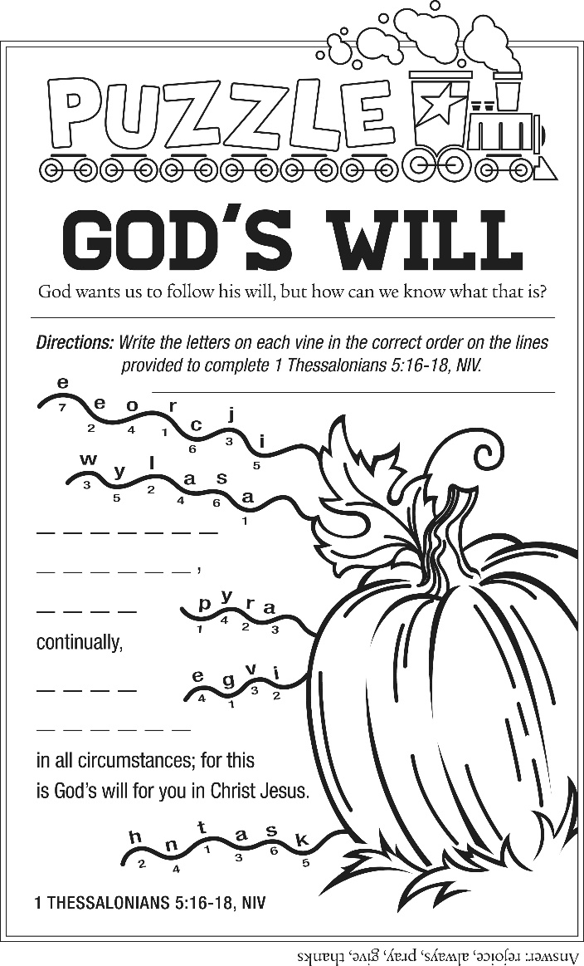



September 2025
Sun | Mon | Tue | Wed | Thu | Fri | Sat
 | 1  LABOR DAY | 2  6:30pm – Finance | 3  1:00pm – Apple Festival Meeting | 4 | 5  5th Quarter  Youth Lock-In | 6
7 | 8  6:15pm – Men’s Chorus  7:00pm – Chancel Choir | 9  1:00pm – UWF  6:30pm – Trustees  7:30pm – Ad. Board | 10 | 11  10:00am – Sr. Citizens | 12 | 13
14 | 15  6:15pm – Men’s Chorus  7:00pm – Chancel Choir | 16  6:00pm – UWF Fellowship | 17 | 18  1:00 pm – Bible Study  (watch bulletin) | 19  5th Quarter | 20
21 | 22 | 23  8:00am Apple Dumpling Baking  6:00pm – 7:30pm – Pre-Order pickup | 24  8:00am Apple Dumpling Baking | 25  10:00am – Sr. Citizens | 26  9:00am – Apple Festival - VV Park Clean Up | 27  11:00am – Apple Festival
28 | 29  7:00pm – Chancel Choir | 30 | Good will come to him who is generous and lends freely, who conducts his affairs with justice.  Psalm 112:5

Notes:

SUNDAY WORSHIP – 9:00 am SUNDAY SCHOOL – 10:30 am
OFFICE HOURS – Tuesday & Thursday – 10:00 am – 12:00 pm
BULLETIN DEADLINE – Thursday – 9:00 am
NEWSLETTER DEADLINE – Third Friday of Month
* Watch bulletin for changes/information

St. Andrew’s U.M. Church
PO Box 221
Valley View, PA 17983
*Address Service Requested

ST. ANDREW’S U.M. CHURCH
“S.A.M.”



SEPTEMBER 2025

