**MAY 2025**

**St. Andrew’s**

**Messenger**

St. Andrew’s United Methodist Church “growing in passion for God, showing compassion to all”

**Our Mission:** “To make disciples of Jesus Christ, who are growing in passion for God and showing compassion to all, by sharing God’s **REPAIR**ingLove.”

**Our Vision:** making disciples through:

**R**adical hospitality

**E**xtravagant generosity

**P**assionate worship

**A**uthentic witness

**I**ntentional faith development

**R**isk taking mission

**Pastor:** Suzanne Elliott

570-682-3508 (Office)

717-253-1263 (Cell)

e-mail: selliott@susumc.org

**Office Hours and Information:**

Secretary – Karen Koppenhaver

Tuesday and Thursday:

10:00 am - 12:00 pm

Phone – 570-682-3508

office@standrewsvalleyview.org

**Newsletter Articles:**

E-mail to the address below:

office@standrewsvalleyview.org

**Prayer Chain Contact:**

Carole Hepler – 570-682-3301

chelper@comcast.net

**St. Andrew’s Web site:** www.standrewsvalleyview.org





*There is a time for everything, and a season for every activity under the heavens.* Ecclesiastes 3:1NIV

Every year for Christmas I am gifted an Almanac. I enjoy reading the articles and each month's weather predictions. One of this year's stories was about flowers and trees that only grow in certain climates. Since I've lived in PA all my life (and don't travel much), I didn't know there was anywhere that didn't enjoy daffodils in the spring! But, it's true! Daffodils need a certain amount of cold weather in order to grow and bloom. The only way they thrive in south Florida is if you put them in the refrigerator all winter!

Winter's cold and rest prepare for the new life in spring. Spring flowers, rain, and warming sun bring about the growth of trees and crops in the summer. The summer growing period gives us the food we need for the next year. The harvest prepares us for the cold and quiet of winter.

This same principle applies to our spiritual lives. The lessons we learn today prepare us for the challenges of tomorrow. Our efforts at prayer and listening for God grow into an important relationship between us and God. Certain seasons are necessary for growing us to our full, beautiful potential! Look for God's unique grace found in this season that can't be found any other time.

Each season of life prepares us for the next and at all times God goes with us!

~Happy Spring!

Pastor Suzanne



**MAY**

**MISSION OF THE MONTH**

**Vacation Bible School**



Save the Date: **June 22-26, 2025**

This year's Vacation Bible School will be **Egypt: Joseph's Journey from Prison to Palace.** We are trying a new curriculum and format to offer a new way for our children to engage with the Scripture. Your financial donations will purchase the curriculum and supplies. Additional opportunities to donate supplies for crafts, decorations, and/or snacks will be provided throughout the month. Thank you for your support of our church's outreach ministry to the children of our community.



Join us for a **Daughter's Day** **Celebration** hosted by the United Women in Faith on **May 7th, @ 6:00pm**, at the church.  Please bring your favorite **covered dish** to be enjoyed by all for dinner.  There will be some fun activities such as Bible trivia and door prizes.  We will also have a special guest to provide good music with a message that honors the Lord.



Sunday, May 18th during 9:00am worship, reception afterwards in Fellowship Hall.

Calling all high school, college, and graduate school graduates. We want to recognize your accomplishments! **Please notify the church office by May 10th with your degree information, future plans, and whether or not you will attend on May 18th**.

2025 CROP Hunger Walk Logo

**Sunday, May 18, 2:00 pm**

The Tri-Valley Ministerium is sponsoring an annual CROP Walk to raise funds for Church World Service's Hunger Ministry. Weather permitting, walkers will walk from the Hepler's Church of God to The Grove and return. The walk is short but does include a hill. **Begin & End at Hepler's Church of God, Pitman**. **Rain or Shine, activities indoors at Hepler's Grove in case of rain.**

Financial donations can be given to any participant or sent directly to the Ministerium. See Pastor Suzanne for further details.



**Annual Conference, May 29-31, 2025**

We will continue to collect 24 pack crayons and 12 pack colored pencils to be donated to Mission Central. Please return your donations to the bin at church by May 25. Thank you for your generosity!

Karen Koppenhaver, Dan Wagner, and Pastor Suzanne will be attending. Please keep all the delegates in prayer.



Congratulations to **Ruby White** who joined the church on April 6 by Profession of Faith after completing Confirmation Class.

A warm welcome to **Sandy Bordlemay** (Stacy Miller's mother) who transferred her membership to St. Andrew's from St. Stephen's United Church of Christ in Lebanon. Sandy resides in Cedar Haven Health Center in Lebanon.



The Youth Group will be holding a weekly Bible Study called **“The Five Principles” – 30 Bible Studies to Help You Combine your Faith and Sports**.

We will meet weekly for 6 weeks, **downstairs from 3:30-5:00pm**.  We will be starting the first principle “Audience of One” which is 6 weeks. After the initial session we will determine the times for each one.

**This is open to all students in the Tri-Valley School district grades 5-12**.

**PEANUT BUTTER COLLECTION**

We collected **75 jars** of peanut butter. These were taken to Valley Lighthouse.

**Thank you to all who donated & thank you to Steve Reitz for delivering.**

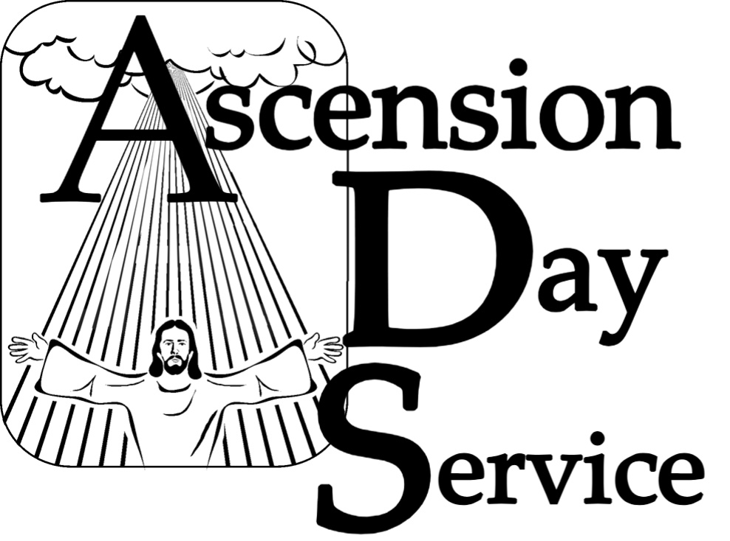

**Thursday, May 29, 2025**

The Tri Valley Ministerium will host an Ascension Day worship service at St. James Lutheran Church, Pitman. Ascension Day is 40 Days after Easter when the risen Christ ascended into heaven.



St. Andrew’s will be hosting a Blood Drive,

Wednesday, May 28th from 2:00pm – 7:00pm. You can make an appointment to donate blood @ [www.redcross.org](http://www.redcross.org) or

by calling 1-800-733-2767.



Please pick up your copy at either entrance doors and allow the scriptures to help you follow God's plan.



**June 8** – Guest Speaker & Special Offering for CEF

Child Evangelism Fellowship will share the message on Sunday, June 8. We will hear from Amy Hautle, this year's youth aged missionary. We will also hear from Shelly Hykes about CEF's ministries. **Advance notice: We will pass the plate**for a one-time offering opportunity to support this ministry.



Traci Timmins (Traci’s Place) has become aware of several elderly individuals and couples in our area who are regularly in need of meals, but who don’t want to trouble other people with their needs.  She has been quietly bringing meals to them, and is now asking if the churches in the area would want to help with this.

Specifically, Traci is inviting people to make a meal for these folks, and then contact her to either pick up the meals, or drop them off at her house.  The meal could be freshly prepared or recently frozen. Out of respect for the recipients’ privacy, Traci would be the point person, and would deliver the meals herself.

If you would be interested in helping with this need right here in our community, please contact Traci at: 570-640-7126.



**Soup Makers Wanted !**

St. Andrews and Pine Creek UM Churches are partnering on a soup sale to benefit the Pine Creek Outreach and other local ministries.

**The following ingredients will be available for pickup.**

***Green Beans, Peas, Tomatoes, Mixed Vegetables, Pasta, Spaghetti Sauce, Rice, Potatoes, Turkey, and Ham****.*

*Some suggestions include – Ham and Green Beans, Vegetable Soup, Turkey Noodle Soup, your choice of others.*

**The items can be picked up Sunday May 11 after church, or throughout the week by calling the church office – 570-682-3508.**

**Soup will be on sale at St. Andrews UMC:**

**Saturday May 17 from 10 am – 2 pm.**

A list of soups will be available, and pre-orders can be placed by calling the church office at 570-682-3508

***************************



**Major Jennifer Renninger**

512 American Legion

Pine Grove, PA 17963



**Chaplain Glenn R. Scheib**

95-957 Wikao Street

Mililani, HI 96789

**Rev. David Wagner**

7517 S. 950 W-92

North Manchester, IN 4696

**Nursing Home – Group Home**

**Assisted Living – Rehab (family)**

**Randy Snyder**

**Vanessa Weaver**

Schuylkill Manor

1000 Schuylkill Manor Road

Pottsville PA 17901

**Tillie Wolfgang**

Pottsville Nursing & Rehab

420 Pulaski Drive

Pottsville, PA 17901

**Gail Bowman**

Providence Place, Pine Grove

24 Hikes Hollow Road

Pine Grove, PA 17963

**Ella Artz, Marilyn Herb, Dolores Stutzman, Larry Wetzel**

Tremont Health & Rehab Center

44 Donaldson Road

Tremont, PA 17981

**Roger Schwalm**

Cedar Haven Healthcare Center

590 S. 5th Avenue

Lebanon, PA 17042

**Sandy Bordlemay**

Seton Manor

1000 Seton Drive

Orwigsburg, PA 17961

**Nancy Klinger**



**The Families of:**

Marie Clark, Lester “Les” Donmoyer, Connie Scheib, Ralph Schwalm, Jo Ann Shade,

Jim Wagner, Ada Wehry



| **MAY 2025** | | | | | | |
| --- | --- | --- | --- | --- | --- | --- |
| **Sun** | **Mon** | **Tue** | **Wed** | **Thu** | **Fri** | **Sat** |
| "For you formed my inward parts; you knitted me together in my mother's womb. I praise you, for I am fearfully and wonderfully made. Psalm 139:13-14 | | | | **1**  **7:00pm – Cemetery Board Meeting** | **2** | **3** |
| **4** | **5**  **6:15pm – Men’s Chorus**  **7:00pm – Chancel Choir** | **6** | **7**  **6:00pm – Daughter’s Day Celebration** | **8**  **10:00am – Sr. Citizens** | **9** | **10** |
| **11**  **Mother’s Day** | **12**  **6:15pm – Men’s Chorus**  **7:00pm – Chancel Choir** | **13**  **6:30pm – Trustees**  **7:30pm – Ad Board** | **14** | **15** | **16** | **17**  **10:00am -2:00pm Soup Sale** |
| **18 Graduate**  **Recognition Sunday**  **Fellowship Hall Rental**  **2:00pm – Crop Walk, Pitman** | **19** | **20**  **1:00pm - UWIF** | **21** | **22**  **10:00am – Sr. Citizens** | **23** | **24** |
| **25** | **26**  **Memorial Day** | **27** | **28**  **2:00pm – 7:00pm Blood Drive** | **29**  **Annual**  **Conference**  **7:00pm Ascension Day Service** | **30**  **Annual Conference**  **11:00am Baccalaureate Rehearsal** | **31**  **Annual Conference** |

**Note**

**SUNDAY WORSHIP** – 9:00 am **SUNDAY SCHOOL** – 10:30 am

**OFFICE HOURS** – Tuesday & Thursday – 10:00 am – 12:00 pm

**BULLETIN DEADLINE** – Thursday – 9:00 am

**NEWSLETTER DEADLINE** – Third Friday of Month

* Watch bulletin for changes



St. Andrew’s U.M. Church

PO Box 221

Valley View, PA 17983

*Address Service Requested

ST. ANDREW’S U.M. CHURCH

“S.A.M.”



**MAY 2025**