**APRIL 2025**

**St. Andrew’s**

**Messenger**

St. Andrew’s United Methodist Church “growing in passion for God, showing compassion to all”

**Our Mission:** “To make disciples of Jesus Christ, who are growing in passion for God and showing compassion to all, by sharing God’s **REPAIR**ingLove.”

**Our Vision:** making disciples through:

**R**adical hospitality

**E**xtravagant generosity

**P**assionate worship

**A**uthentic witness

**I**ntentional faith development

**R**isk taking mission

**Pastor:** Suzanne Elliott

570-682-3508 (Office)

717-253-1263 (Cell)

e-mail: selliott@susumc.org

**Office Hours and Information:**

Secretary – Karen Koppenhaver

Tuesday and Thursday:

10:00 am - 12:00 pm

Phone – 570-682-3508

office@standrewsvalleyview.org

**Newsletter Articles:**

E-mail to the address below:

office@standrewsvalleyview.org

**Prayer Chain Contact:**

Carole Hepler – 570-682-3301

chelper@comcast.net

**St. Andrew’s Web site:** www.standrewsvalleyview.org

****



**Holy Week Worship**

\*\*Livestreaming will be provided for 9:00am Sunday services and Maundy Thursday service\*\*

**Sunday, April 13**

**Palm/Passion Sunday – 9:00am**

The service will begin with a Palm Sunday celebration before transitioning to a reading of the entire Passion Narrative.

**Thursday, April 17**

**Maundy Thursday – 7:00pm**

This service will remember Jesus' institution of the Sacrament of Holy Communion.

**Friday, April 18**

**Good Friday Crosswalk – 12:15pm**

Join members of the community as we take turns carrying a cross through the streets of Valley View. We will stop at area churches for a devotional reading. If you have trouble walking, you can drive to each location. Start and end at St. Andrew's

**Good Friday Worship – 7:00pm**

Tri-Valley Ministerium

Rev. Mike Klahr at Friedens UCC, Hegins

**Sunday, April 20**

**Easter Sunrise Service – 6:30am**, outside in the cemetery, weather permitting    A great way to celebrate the Resurrection! Holy Communion included. Some folding chairs

provided. Coffee and donuts in the Social Hall afterwards.

**Easter Celebration Worship – 9:00am**

The Lenten worship series will conclude with Alleluia! - a word that truly lasts forever.

****

**From the Pastor**

Happy Easter everyone! This is our best story as Christians - the story of life that wins over death. Here at St. Andrew's, we will tell this story several ways: scripture, hymns, choir anthem, sermons, and drama. We will tell the story in different ways to our children and to our adults. We will have fun and we will be reverent. This is our best story and our greatest celebration! Alleluia!

I hope you enjoy this recipe as yet another way to tell about the resurrection.

Christ is Alive! Let Christians sing (and bake)!

~Pastor Suzanne

**Resurrection Cookies**

\*These cookies need to sit in the oven overnight\*

Needed:

1 c. pecans or mini chocolate chips

3 egg whites

1 tsp. white vinegar

1 c. sugar

pinch of salt

Preheat oven to 350. Use a metal or glass bowl, not plastic. Do not include any yolks with the egg whites.

1. Place pecans in a plastic baggie. Beat with a mallet until they are in small pieces. This reminds us that Jesus was arrested and beaten by the Roman soldiers. **Read John 19:1-3**

2. Smell the vinegar. Remember that Jesus had to drink this when he hung on the cross. **Read John 19:28-30.** Add vinegar to the bowl.

3. Add egg whites to the bowl. Eggs represent life. Remember that Jesus gave his life so that we can have life eternal. **Read John 10:10-11**

4. Take a little taste of the salt. This reminds us of salty tears shed by Jesus' followers and the bitterness of our sin. **Read Luke 23:27** Add a pinch of salt to the bowl.



Confirmation Sunday - April 6   9:00am

Join us as we celebrate Profession of Faith and Membership for **Ruby White**. A reception with refreshments will follow the worship service in the Social Hall.

lilybord

5. Add the sugar. The sweetest part of the story is that Jesus loves us so much. **Read Psalm 34:8 and John 3:16**

6. Beat the egg white mixture to form peaks, about 10-12 minutes. The white color reminds of the purity of our hearts when we are forgiven of our sins. **Read Isaiah 1:18 and John 3:1-3**

7. Carefully fold in the nuts or mini chocolate chips. Drop by teaspoonful onto a parchment paper covered cookie sheet. Each mound represents the rocky tomb where Jesus was buried. **Read Matthew 27:57-60**

8. Place cookie sheet in preheated oven and turn the oven OFF. Use masking tape to seal the oven just as the tomb was sealed shut. **Read Matthew 27:65-66**

9. Go to bed! You may be sad to leave the cookies in the oven overnight just as Jesus' followers were sad when the tomb was sealed and they had to leave his body there. **Read John 16:20,22**

10. In the morning, open the oven and taste a cookie. You will discover that the center is empty just like the women discovered that the tomb was empty on Easter morning. **Read Matthew 28:1-9**

**APRIL**

**MISSION OF THE MONTH**

**SERVANTS TO ALL**

Servants to All is a 501 C (3), non-profit organization serving all of Schuylkill County.

They provide homeless services, temporary housing, homeless prevention, street outreach, case management and supportive services, which include emergency food, clothing, transportation, prescription co-

pays and assistance obtaining personal documents. Servants to All also assists those

who are either homeless, at risk of homelessness or experiencing other extreme

financial difficulty. There are no fees charged to anyone who receives services from Servants to All.

We will be collecting the following items:

HYGIENE ITEMS: shampoo / feminine products / toothpaste / deodorant / soap /

wet wipes / disposable razors / body or hand lotion / towels.

CLEANING SUPPLIES: toilet paper / all purpose cleaner / laundry detergent /

hand sanitizer.

Items may be placed in the bin located in the Fellowship Hall during the month of April.

Thank you for your support of this critical ministry in Schuylkill County.



Once again, this year our District is collecting Peanut Butter to bless local families and food pantries. Peanut butter is one of the most frequently requested items by food banks because it is kid-friendly, shelf-stable, and protein-rich. It is a tasty, versatile, and nutrient-dense food. "Non peanut" butters such as sunflower butter are also appreciated due to nut allergies.

You can bring your peanut butter to church by **April 13**. We will keep a count of our donations. The District-wide goal is 6,075 jars.



The Community Service Night held for the High School students, grades 9-12 was a great success. Without all of you who

donated items and time, we could not have accomplished what we did. Not only did our students receive hours, but Mission Central received much needed items for their mission support.

**IGNITE Children’s Ministry SPRING 2025**

St. Andrew’s UMC, Valley View

Preschool -Grade 5 Please RSVP



**Our Greatest Story – Easter**

**Sunday, April 13 1:00-3:00pm**

Join us as we tell the story of Jesus’ Resurrection with music, crafts, games, snack, and drama.



Congratulations to Pastor Suzanne as the recipient of the United Women in Faith's Special Mission Recognition for her service on many committees and outreaches that enrich the lives of women, children and youth of St. Andrews and our community.

**Mission Central - Collection of Items for AC**

We will be collecting items to go along to Annual Conference for Mission Central. Our district, River Valley is asked to collect:

24-Pack Crayons and 12-Pack Colored Pencils.

We will have a bin for collecting items.

****

Come join us for a Daughter's Day celebration hosted by the United Women in Faith on May 7th at the church.  Please bring your favorite covered dish to be enjoyed by all for dinner.  There will be some fun activities such as bible trivia and door prizes.  We will also have a special guest to provide good music with a message that honors the Lord.  Sign-up sheets will be placed in the Social Hall during the month of April.



Zion Church, Erdman will be holding a Fundraiser, **April 25th**, featuring a PA Dutch treat…Fish Pie. A thick, chewy, sugar cookie crust filled with a molasses filling…Oh so good!

This will be a **Drive thru Pick-up event, 3:00pm – 4:00pm.**

There are two sizes available:

**9” Deep Dish - $13 or 5 1/2” Deep Dish - $7**

**Please call 570-425-2256 to place order.**





**Major Jennifer Renninger**

512 American Legion

Pine Grove, PA 17963

**Nursing Home – Group Home**

**Assisted Living – Rehab (family)**

**Randy Snyder**

**Vanessa Weaver**

Schuylkill Manor

1000 Schuylkill Manor Road

Pottsville PA 17901

**Tillie Wolfgang**

Pottsville Nursing & Rehab

420 Pulaski Drive

Pottsville, PA 17901

**Gail Bowman**

Providence Place, Pine Grove

24 Hikes Hollow Road

Pine Grove, PA 17963

**Ella Artz, Marilyn Herb, Dolores Stutzman, Larry Wetzel**

Tremont Health & Rehab Center

44 Donaldson Road

Tremont, PA 17981

**Jo Ann Shade, Roger Schwalm**

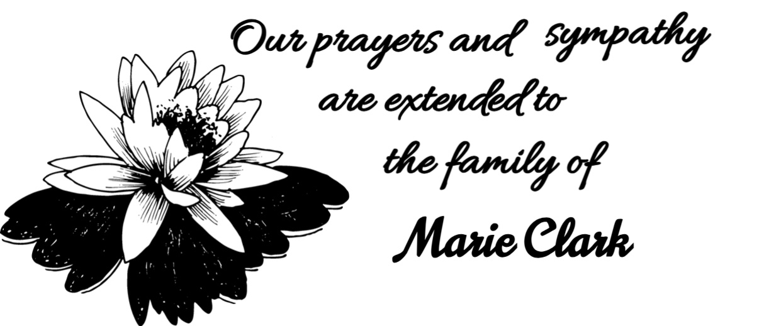



**Chaplain Glenn R. Scheib**

95-957 Wikao Street

Mililani, HI 96789

**Rev. David Wagner**

7517 S. 950 W-92

North Manchester, IN 4696



| **APRIL 2025** | | | | | | |
| --- | --- | --- | --- | --- | --- | --- |
| **Sun** | **Mon** | **Tue** | **Wed** | **Thu** | **Fri** | **Sat** |
| crosses_29688 | | **1** | **2**  **7:00pm – Lenten Service St. Andrew’s UMC, VV** | **3**  **10:00am – Lenten Bible Study**  **11:30am-1:30pm – OFFICE HOURS** | **4** | **5**  **7:00am - Lenten Breakfast** |
| **6**  **Confirmation Sunday** | **7**  **6:15pm – Men’s Chorus**  **7:00pm – Chancel Choir** | **8**  **6:30pm – Trustees**  **7:30pm – Ad. Board** | **9**  **7:00pm – Lenten Service**  **Friedens Lutheran, Hegins** | **10**  **10:00am – Lenten Bible Study**  **10:00am – Sr. Citizens**  **11:30am-1:30pm – OFFICE HOURS** | **11** | **12**  **7:00am - Lenten Breakfast** |
| **13 PALM**  **SUNDAY**  **1:00PM -3:00PM IGNITE** | **14**  **6:15pm – Men’s Chorus**  **7:00pm – Chancel Choir** | **15**  **1:00pm – UWIF** | **16** | **17 MAUNDY**  **THURSDAY**  **7:00pm – Maundy Thursday Service**  **St. Andrew’s** | **18 GOOD**  **FRIDAY**  **12:15pm – Cross Walk, St. Andrew’s**  **7:00pm – Good Friday Service, Friedens UCC, Hegins** | **19** |
| **20 EASTER**  **6:30am – Sunrise Service** | **21** | **22** | **23** | **24**  **10:00am – Sr. Citizens** | **25** | **26** |
| **27** | **28**  **6:15pm – Men’s Chorus**  **7:00pm – Chancel Choir** | **29** | **30** | But God proves His love for us in this: While we were still sinners, Christ died for us. [**Romans 5:8**](https://biblehub.com/romans/5-8.htm) | | |

**Note**

**SUNDAY WORSHIP** – 9:00 am **SUNDAY SCHOOL** – 10:30 am

**OFFICE HOURS** – Tuesday & Thursday – 10:00 am – 12:00 pm

**BULLETIN DEADLINE** – Thursday – 9:00 am

**NEWSLETTER DEADLINE** – Third Friday of Month

\* Watch bulletin for changes.



St. Andrew’s U.M. Church

PO Box 221

Valley View, PA 17983

\*Address Service Requested

ST. ANDREW’S U.M. CHURCH

“S.A.M.”



**APRIL 2025**