St. Andrew’s
Messenger
St. Andrew’s United Methodist Church “growing in passion for God, showing compassion to all”
Our Mission: “To make disciples of Jesus Christ, who are growing in passion for God and showing compassion to all, by sharing God’s REPAIRing Love.”
Our Vision: making disciples through:
Radical hospitality
Extravagant generosity
Passionate worship
Authentic witness
Intentional faith development
Risk taking mission

Pastor: Suzanne Elliott
570-682-3508 (Office)
717-253-1263 (Cell)
e-mail: selliott@susumc.org

Office Hours and Information:
Secretary – Karen Koppenhaver
Tuesday and Thursday:
10:00 am - 12:00 pm
Phone – 570-682-3508
office@standrewsvalleyview.org

Newsletter Articles:
E-mail to the address below:
office@standrewsvalleyview.org

Prayer Chain Contact:
Carole Hepler – 570-682-3301
chelper@comcast.net

St. Andrew’s Web site: www.standrewsvalleyview.org


DECEMBER 2024


St. Andrew’s Nativity Scene
The Christian Endeavor Society of the Evangelical United Brethren Church purchased a Nativity scene in the late 50’s. It was from Mardough’s Christmas Barn in Robesonia.
After many years of service, it was time to replace the figurines. They had gone from faded colors to a white coat finish.
In 2018 it was time for a brand-new set. They were purchased from the same company and picked up in Robesonia.
Memorial gifts from faithful members paid for the new figurines. The families of these ladies: Isabel Romberger, Irene Ossman, and Dora Bair contributed.
Now the Nativity has a larger, new stable built by Jerry Krammes.
Take time to view and enjoy the true meaning of the season. It is an expression of our faith to the community.

Graciously submitted by
Mary Ellen Krammes

Advent & Christmas
Worship Series
Based on The Christmas Experience by Kyle Idleman
December 1,8,15,22
"The Christmas Experience shows us that Jesus is worth waiting for. His coming into the world may not make our circumstances easier - in fact, like many who experienced the first Christmas, the very opposite may be true - but he does give our lives purpose and true joy. He brings a joy that the world cannot give or understand." Video and discussion during the Sunday School hour in the Social Hall.

St. John’s Advent Hymn Sing
Sunday, December 1, 7:00pm
Join St. Andrew's Chancel Choir and others from our community as we kick off the Advent season.


A group from St. Andrew's is going on Friday, December 6. If you want to carpool, meet in the church parking lot for a 5:15pm departure. We will stop for supper afterwards. See Pastor Suzanne with any questions.


Another year is coming to a close, and it’s time for the Prayer Pal Reveal Party!!!!
First, let me say a huge thank you to all our parents who signed up your children for this ministry, as well as for all the adults who committed to consistently pray for a child! Without your involvement, this ministry would not happen! I pray you all found this year to be a blessing as you participated in the ministry. Our children have been waiting a whole year to find out who has been their Prayer Pal! On Sunday, December 8, we will hold a Prayer Pal Reveal Party to find out! The party will be held downstairs after worship, beginning at 10:30. The theme for this year’s party is, “Linked Together”. There will be refreshments, games and a time of fellowship as prayer pals are revealed! Please mark your calendar and be sure to plan on joining us for this fun event! Again, thanks to all of you who participated in this year’s Prayer Pal Ministry.

BLUE CHRISTMAS SERVICE
DECEMBER 8, 3:00PM
St. Paul’s UCC, 2300 East Main St., Sacramento, PA
As the Christmas season and all its trimmings begin to dominate our thoughts and community, are you dreading the holiday? Not feeling very “holly, jolly”? Then join us for this year's "Blue Christmas" Service.
A Blue Christmas Service is for people who feel “blue” at this time of year, people who feel the darkness of winter pressing in on them. It is for people who are grieving the loss of a loved one, a broken relationship, or other disappointments, which make the holiday season a difficult time to be happy.
If you or someone you know is grieving or sad this holiday, please join us for a Tri-Valley Ministerium Blue Christmas Service at St. Paul’s UCC in Sacramento. All are invited to come and acknowledge the need for comfort during this holiday season. For more information, call 570-682-9828.

*************************************
Ignite Christmas
Children grades K-5th
Friday, December 13 5:00-8:00pm
Saturday, December 14, 9:00-Noon
Let’s have some Christmas fun as we remember the real reason for the season.
You are invited to attend one or both sessions. They will not be the same. Dinner will be provided on Friday. Lunch will be provided on Saturday. Sign-up requested.

CHRISTMAS OFFICE HOURS
The office hours for the week of Christmas will be as follows.
Monday, 12/23/24 – 10:00am – 12:00pm
CLOSED TUESDAY, 12/24/24
Thursday, 12/26/24 – 10:00am – 12:00pm
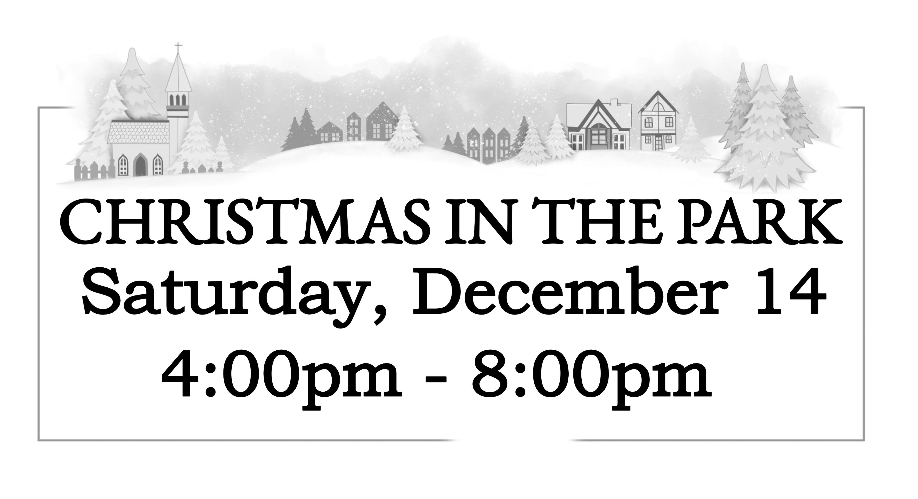

2025 PRAYER PAL SIGN UP
Beginning on Sunday, December 15, 2024, you will have the opportunity to sign up your children to participate in the Prayer Pal Ministry. It will also be the date for adults to sign up to be Prayer Pals. The sign-up sheets will be available in the fellowship hall each Sunday beginning Dec. 15 through Dec 29, 2024. I would like to be able to have the new Prayer Pal match ups complete by the second Sunday in January. Please prayerfully consider having your child participate in this ministry. Adults, please prayerfully consider being a prayer pal for one of the children of our congregation. If anyone has any questions, please see Mary Ellen Klebe. Thank you to everyone who participates in this ministry of prayer for our children!


Sunday, December 15, 7:00pm
St. Andrew's Sanctuary
Choirs from Christ UCC, St. Andrew's, St. Paul UCC, and Trinity Lutheran will join to share the message of Christ's birth in song. There will be songs from each individual choir as well as two pieces from the mass choir.


Christmas Caroling
Wednesday, December 18
5:30pm
Meet in the church parking lot to carpool to church family and friends who are homebound. If you can't make it that early, contact Cathy Miller at 570-205-1432 and we will make arrangements to swing back through the church parking lot to meet up with you. Light supper is provided at the church afterwards.

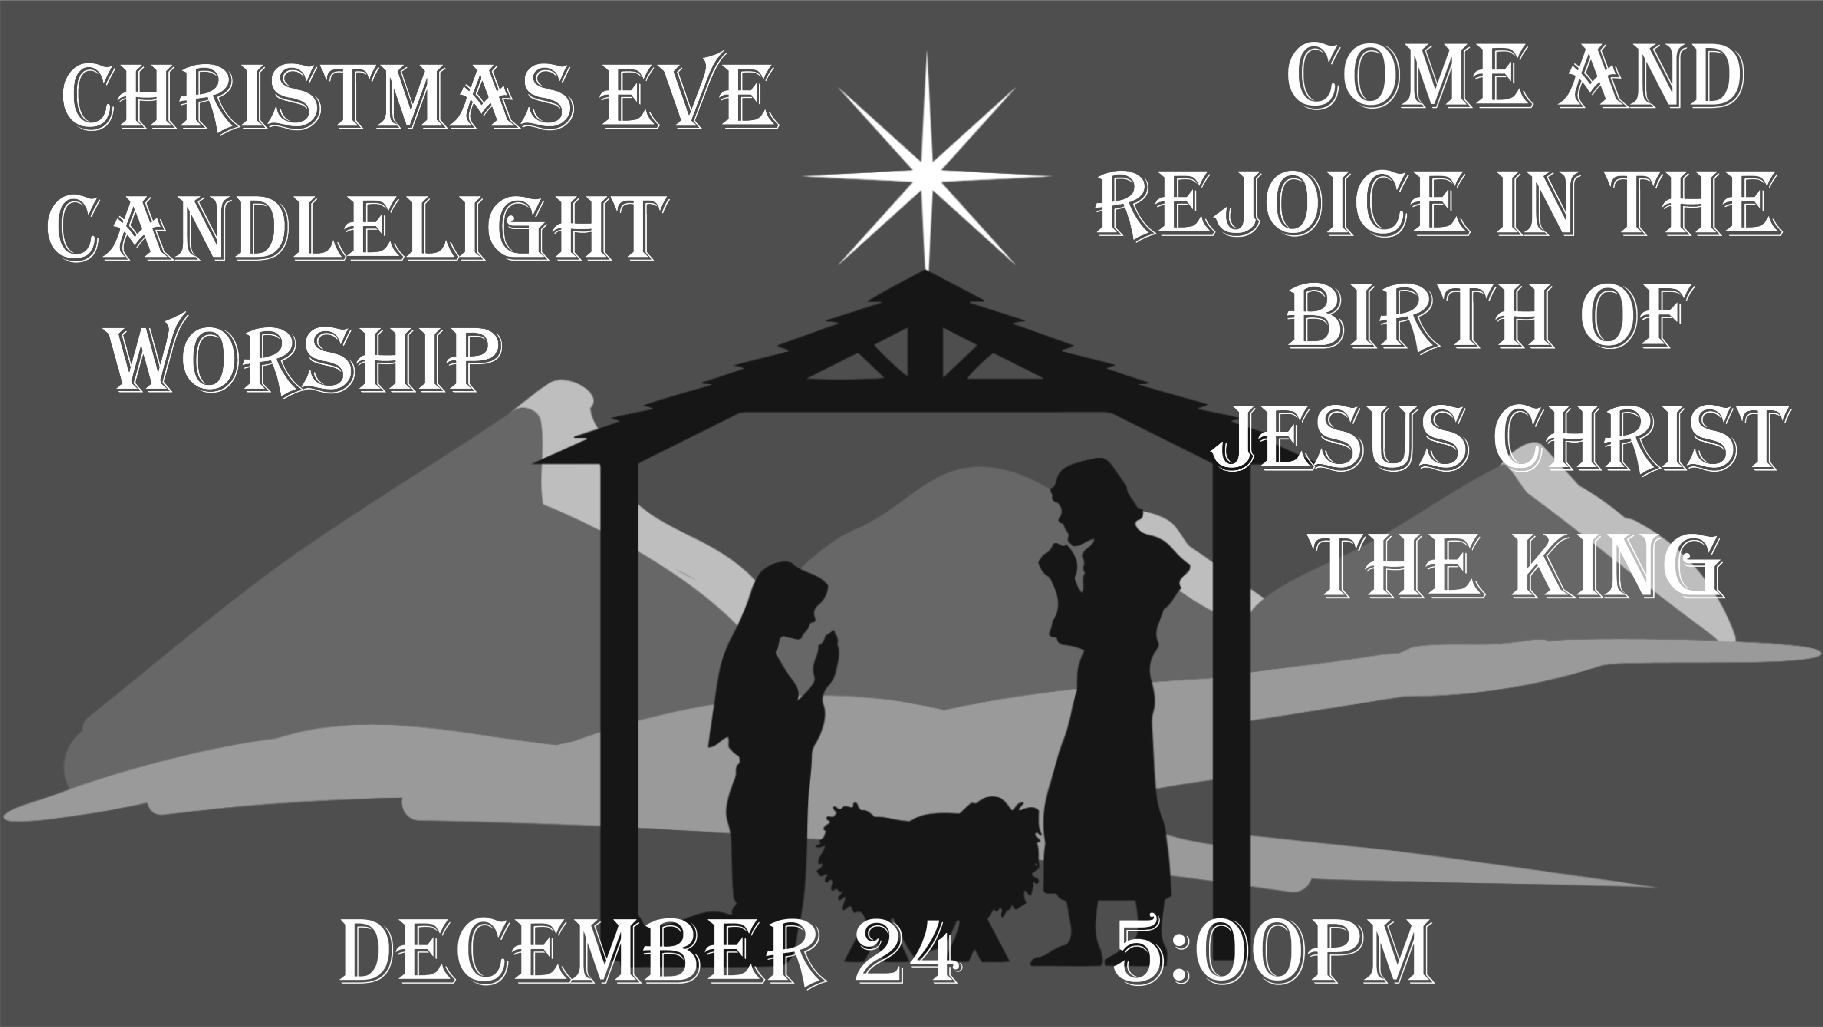

Community Service Night Thanks
Thank you again for all of your support for this new outreach opportunity. Thanks for your donations of food and supplies. And thanks to those who gave their time to make this a success.
There were more than 30 teens at each event in October and November. When asked, the youth in attendance expressed enthusiastic support for offering another event in the spring.
With this ministry, everyone wins! Our church connects with youth from our community. Students at the High School gain community service hours. Charities benefit from our donations.

UMCOR Donation at
Church Conference
At the cluster Church Conference on November 3 an offering was taken to benefit UMCOR hurricane relief. A total of $806.00 was collected. Wonderful!

Thank You
St. Andrew’s,
Thank you so much for the donations for all the bookbags filled with essentials. These bookbags really mean a lot to children who have very little or need something comforting in a scary situation. The Agency and children really appreciate your kindness.
Schuylkill County Children & Youth


Anyone grade 6 through adult is welcome to join this year's Confirmation Class. Students will explore their faith and prepare to make a commitment to Jesus Christ and join the church. Classes will begin in January. Day and time based on the availability of the group. See Pastor Suzanne to enroll.


Chaplain Glenn R. Scheib
95-957 Wikao Street
Mililani, HI 96789

Rev. David Wagner
7517 S. 950 W-92
North Manchester, IN 46962


Major Jennifer Renninger
512 American Legion
Pine Grove, Pa 17963

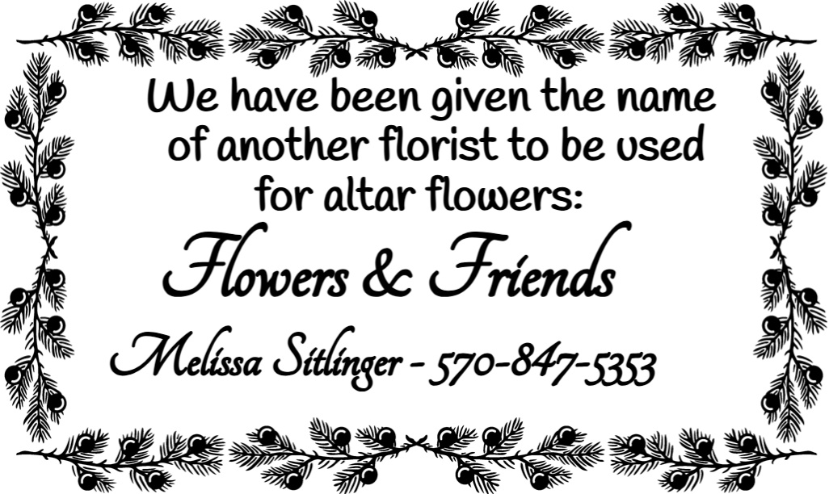



Nursing Home – Group Homes
Assisted Living – Rehab (family)

Randy Snyder
Vanessa Weaver

Schuylkill Manor
1000 Schuylkill Manor Road
Pottsville PA 17901
Tillie Wolfgang

Pottsville Nursing & Rehab
420 Pulaski Drive
Pottsville, PA 17901
Gail Bowman
Providence Place, Pine Grove
24 Hikes Hollow Road
Pine Grove, PA 17963
Ella Artz, Marilyn Herb

Tremont Health & Rehab Center
44 Donaldson Road
Tremont, PA 17981
Jo Ann Shade, Roger Schwalm



December 2024
Sun | Mon | Tue | Wed | Thu | Fri | Sat
1  7:00pm –  St. John’s Christmas Hymn Sing | 2  6:15pm – Men’s Chorus  7:00pm – Chancel Choir | 3  1:00pm - UWIF | 4 | 5 | 6  5:15pm – Walk Through Bethlehem | 7
8  Prayer Pal Reveal – Sunday School Hour  3:00pm – Blue Christmas | 9  6:15pm – Men’s Chorus  7:00pm – Chancel Choir | 10  6:30pm – Trustees  7:30pm – Ad. Board | 11 | 12  10:00am – Sr. Citizens | 13  5:00pm-8:00pm - IGNITE | 14  9:00am – 12:00pm – IGNITE  Christmas in the Park
15  7:00pm – Community Choir  Program | 16 | 17 | 18  5:30pm - Caroling | 19 | 20 | 21
22 | 23  OFFICE HOURS  10:00am – 12:00pm | 24  5:00pm - Christmas Eve Service | 25  MERRY  CHRISTMAS | 26 | 27 | 28
29 | 30 | 31 | 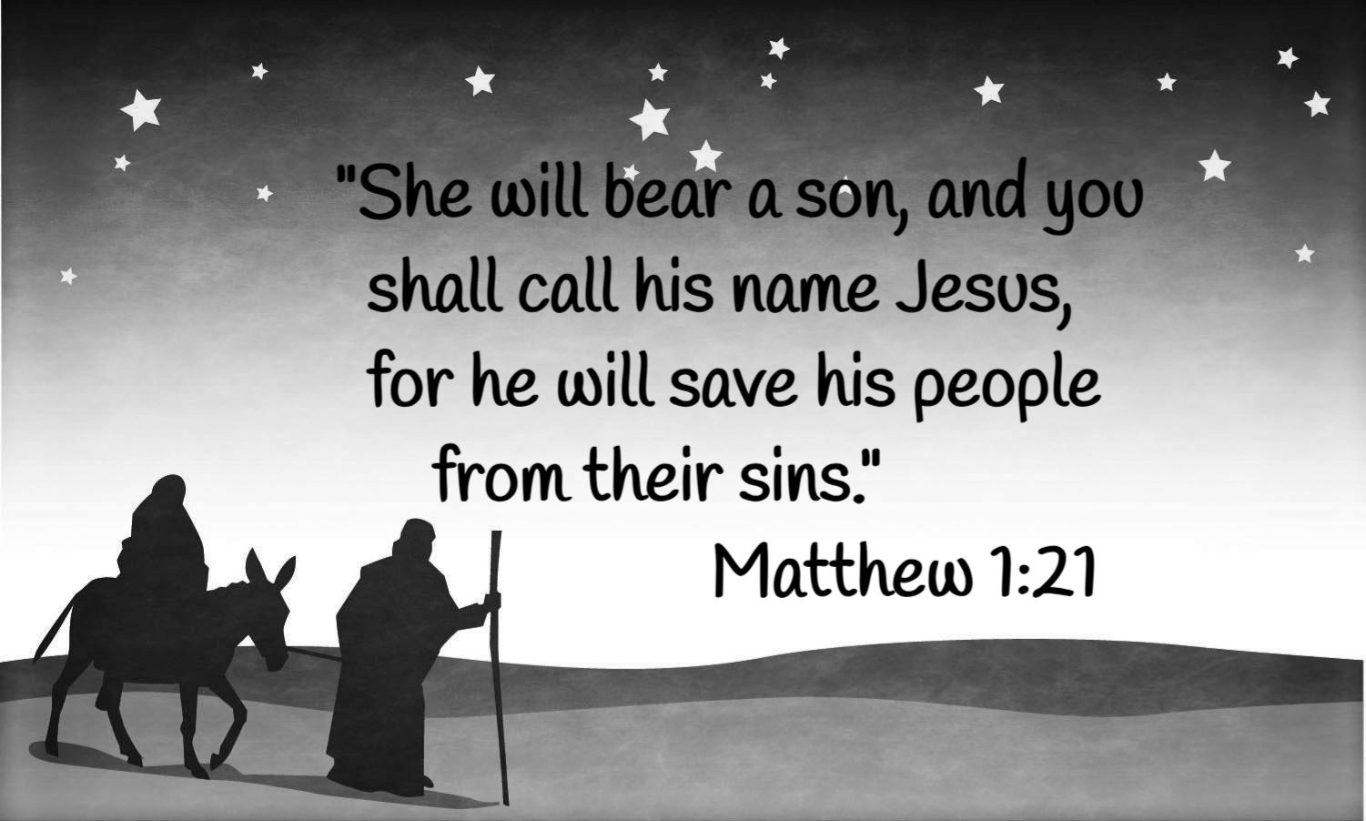
NOTES:


St. Andrew’s U.M. Church
PO Box 221
Valley View, PA 17983
*Address Service Requested

ST. ANDREW’S U.M. CHURCH
“S.A.M.”



December 2024

