**St. Andrew’s**

**Messenger**

St. Andrew’s United Methodist Church “growing in passion for God, showing compassion to all”

**Our Mission:** “To make disciples of Jesus Christ, who are growing in passion for God and showing compassion to all, by sharing God’s **REPAIR**ingLove.”

**Our Vision:** making disciples through:

**R**adical hospitality

**E**xtravagant generosity

**P**assionate worship

**A**uthentic witness

**I**ntentional faith development

**R**isk taking mission

**Pastor:** Suzanne Elliott

570-682-3508 (Office)

717-253-1263 (Cell)

e-mail: selliott@susumc.org

**Office Hours and Information:**

Secretary – Karen Koppenhaver

Tuesday and Thursday:

10:00 am - 12:00 pm

Phone – 570-682-3508

office@standrewsvalleyview.org

**Newsletter Articles:**

E-mail to the address below:

office@standrewsvalleyview.org

**Prayer Chain Contact:**

Carole Hepler – 570-682-3301

chelper@comcast.net

**St. Andrew’s Web site:** www.standrewsvalleyview.org

****

**SEPTEMBER 2024**



"When Abram was 99 years old, **ADONAI** appeared to Abram and said to him, "I am **El Shaddai** (God Almighty), walk before me and be blameless."   Genesis 17:1

This summer we have been studying the I AM names of Jesus found in the Gospel of John. Each one tells us something special about Jesus' identity and purpose. Each one pulls us back to the name that God revealed to Moses at the burning bush:

"**I AM**." Jesus IS God but he is also God revealed in human form for us to understand. We could easily take longer than one summer to study these profound statements by Jesus.

The Nazarene Church in Lavelle has been studying the names of God this summer (according to the sign in their yard). I also happened upon a little book called "His Names are Wonderful: Getting to Know God Through His Hebrew Names." It seemed like a Holy Spirit moment! The names of Jesus followed up by the names of God! Then I discovered that there are over 140 names of God in scripture. That would take more than one summer of study! Sounds like a topic for independent study, not a sermon series.

Here are just a few of God's names in Hebrew and where they are found in scripture. I hope you check them out. Each one tells us something special about who God is.

**Abba** (Dear Father) Isaiah 63:16, Matthew 6:8-10, Romans 8:14-16

**El Nosey** (Forgiving God) Micah 7:18, Psalm 99:8, Matthew 26:28, Ephesians 1:7-8

**Etzarkhah Va'Beten** (God Who Formed Us in the Womb) Jeremiah 1:5, Psalm 139:13-16

**Avi'ad**(God of Eternity) Isaiah 9:5, Jeremiah 10:10, Psalm 41:14, John 14:2-3

The more we know about God, the more we know about the One who loved us enough to send His Son to die for us.

It's back to school time. Maybe it's "Back to Bible" time too!  Deepen your knowledge. Grow your faith.

With you on the faith journey,

~Pastor Suzanne

**MISSION OF THE MONTH**



September's Mission of the Month is Mission Central. Mission Central is a warehouse in Mechanicsburg started by our Conference to provide Mission Outreach, Mission Education, and Disaster Supplies to partners all over the world. Mission Central has been busy providing resources to communities affected by the recent flooding. This seemed like just the right time to support them in their work!



**Apple Festival**

**September 28, 11:00am – till Sold Out**

**Valley View Park**

We are gearing up for another great Apple Festival. We will need lots of help. See Roger Wetzel or Lori Klinger to volunteer!

Apple Dumplings - $5.00 each

Pre-orders: August 25-September 15

Pre-order pickup: Tuesday, Sept. 24

6:00-7:30pm at church

Dumpling baking: September 24 & 25 beginning at 8:00am. Donuts, coffee, and lunch will be provided.

Sign Up sheets to donate pies, baked goods, and soups are all available in the Fellowship Hall.

Be sure to stop by the park on the 28th and support our efforts!  Available for purchase: apple cider, applesauce, apple butter, apple pies, apple dumplings, apple desserts, hot dogs, soups, drinks.



**AMPED UPDATE FALL OF 2024**

Every Sunday in our bulletin we see John Wesley’s 3 rules for Christian living: DO NO

HARM, DO GOOD, STAY IN LOVE WITH GOD. This fall in Amped, our children will be

learning from a series of lessons designed specifically for children by Adam Hamilton

based on these 3 rules.

We will have 2 lessons for each rule and will explore what those rules mean and how

we can live them out in our daily lives. The lessons will be very interactive and will help

children learn what it means to be a Christian living in today’s world in such a way as to

do no harm, do good, and stay in love with God.

Amped is open to all children ages 3 through 4th grade and is held each Sunday during

our worship time. Our teachers and helpers have their clearances and our church

training, so are qualified to work with children, as per our churches protocol.

I would like to thank all our teachers and helpers for your desire to be a part of this vital

program teaching children about the love of God through Jesus. Thank you for your

commitment, time, and using your abilities to further God’s word!

The lessons for the teachers are available on the table in the fellowship hall. Amped will

begin on **Sunday,** **September 8, 2024**. I look forward to having a great year of Amped

and seeing our children grow in their love and knowledge of Jesus and God’s love!

Mary Ellen Klebe, Amped Coordinator

fall_4177

****

We are gearing up for another year of 5th Quarter following each home football game. Donations of soda, chips, and pre-packaged snacks are welcome. Volunteers are needed (must have all background checks submitted). See Steve Reitz for more information.

**HOME GAME DATES**

September 13

September 27

October 18

October 25

Any home playoff games

border_28804

**United Women in Faith - Joint Meeting**

Reminder to all ladies that our annual joint meeting with St. John's UMC United Women in Faith will be held on **Thursday, September 15 at 6:00pm at St. John's.** Bring a potluck dish to share for supper.  All ladies are welcome to attend.

Safe Sanctuaries Reminder

Any volunteer who works with our children or youth is required to have the following background checks completed and on file with Cathy Miller. These clearances must be updated every 5 years. Cathy and Pastor Suzanne are checking to be sure that **all** paperwork is completed. **You may be asked to not volunteer until everything is submitted.**

1. State Police

2. PA Dept of Human Services

3. Volunteer Affidavit (notarized) or FBI fingerprinting

4. Ministry Safe online training

The following current ministries require background checks:

AMPED, 5th Quarter, VBS, Ignite, Youth Group

**Volunteers in Medicine/Gaudenzia**

St. Andrew's parking lot will be host to a bus from Volunteers in Medicine/Gaudenzia every **3rd Wednesday from 10:00am-2:00pm**. Gaudenzia provides addiction treatment services and Volunteers in Medicine provides free basic healthcare. This mobile unit is trying to expand into our area to provide needed services.

Volunteer doctors, nurses, and social workers are needed to make this venture successful. Contact Pastor Bob Alonge for more information 570-623-1113.

****

Thank you for hosting another successful Blood Drive. The goal was 26 units and **36** were collected…Way to Go! A special thank you to everyone who volunteered to help.

God Bless,

Carol Herb, Tri-Valley Blood Drive Coordinator

**THANK YOU**

**CEF** would like to thank St. Andrew’s for the Contribution from our July Mission of the Month. A total of $345 was collected and was used for the Summer Missions and supported Chris Hautle, Missionary who shared his CEF work with St. Andrew’s members.

border_28804

Fall Music Festival

**Saturday, September 14 @ 12:00pm-6:00pm** Hepler's Church of God - Fall Music Festival, Hepler's Church Grove featuring

Heaven 4 Shore and Jared & Katie Wehry.

See flier on Narthex bulletin board.

**Nursing Home – Assisted Living-**

**Group Homes – Rehab, (family)**

**Randy Snyder**

**Vanessa Weaver**

Schuylkill Manor

1000 Schuylkill Manor Road

Pottsville PA 17901

**Tillie Wolfgang**

Pottsville Nursing & Rehab

420 Pulaski Drive

Pottsville, PA 17901

**Gail Bowman**

Providence Place, Pine Grove

24 Hikes Hollow Road

Pine Grove, PA 17963

**Ella Artz, Marilyn Herb**

Tremont Health & Rehab Center

44 Donaldson Road

Tremont PA 17981

**Jo Ann Shade, Roger Schwalm**

border_28804



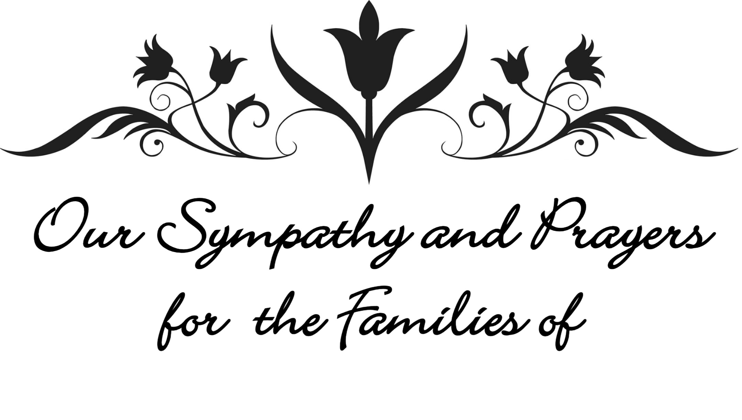

Jim Artz (Hegins) Mary Bardo Sandy Deiber Bill Gilbert Mary Groff Earl Kissinger, Jr. Betty Klinger Margie Kufrovich Larry Lucas Frank Montgomery Trent Otto Tom Radel James Reider Clayton Rhoades John Shade Mike Shade(Spring Glen) Jeanette Zerbe



**Major Jennifer Renninger**

512 American Legion

Pine Grove, Pa 17963



**Chaplain Glenn R. Scheib**,

95-957 Wikao Street Mililani, HI 96789

**Rev. David Wagner**

7517 S. 950 W-92 North Manchester, Indiana 46962



| **September 2024** | | | | | | | | | |
| --- | --- | --- | --- | --- | --- | --- | --- | --- | --- |
| **Sun** | | **Mon** | | **Tue** | **Wed** | **Thu** | **Fri** | **Sat** | |
| 1 | | 2  **LABOR DAY** | | 3 | 4  7:00 pm Nominations Committee | 5 | 6 | 7 | |
| **8** | | **9** | | 10  6:30pm – Trustees  7:30pm – Ad. Board | 11  7:00pm – Finance Committee | 12  10:00am – Sr. Citizens  6:00pm – UWIF @ St. John’s | 13  5th Quarter | 14  12:00pm – 6:00pm - Hepler’s Church of God Fall Festival | |
| 15 | 16 | | 17 | | 18  10:00am – 2:00pm – Gaudenzia Mobile Unit | 19 | 20 | | 21 |
| 22 | 23 | | 24  8:00am Apple Dumpling Baking  6:00pm – 7:30pm – Pre-Order pickup | | 25  8:00am Apple Dumpling Baking | 26  10:00am – Sr. Citizens | 27  9:00am – Apple Festival - VV Park Clean Up  5th Quarter | | 28  11:00am – Apple Festival |
| 29 | 30 | | This is to my Father’s glory, that you bear much fruit, showing yourselves to be my disciples. [John 15:8](https://dailyverses.net/john/15/8) | | | | | | |
| **Notes:**  **SUNDAY WORSHIP** – 9:00 am **SUNDAY SCHOOL** – 10:30 am  **OFFICE HOURS** – Tuesday & Thursday – 10:00 am – 12:00 pm  **BULLETIN DEADLINE** – Thursday – 9:00 am  **NEWSLETTER DEADLINE** – Third Friday of Month  **\*** Watch bulletin for changes/information | | | | | | | | | |



St. Andrew’s U.M. Church

PO Box 221

Valley View, PA 17983

\*Address Service Requested

ST. ANDREW’S U.M. CHURCH

“S.A.M.”



**September 2024**