**St. Andrew’s**

**Messenger**

St. Andrew’s United Methodist Church “growing in passion for God, showing compassion to all”

**Our Mission:** “To make disciples of Jesus Christ, who are growing in passion for God and showing compassion to all, by sharing God’s **REPAIR**ingLove.”

**Our Vision:** making disciples through:

**R**adical hospitality

**E**xtravagant generosity

**P**assionate worship

**A**uthentic witness

**I**ntentional faith development

**R**isk taking mission

**Pastor:** Suzanne Elliott

570-682-3508 (Office)

717-253-1263 (Cell)

e-mail: selliott@susumc.org

**Office Hours and Information:**

Secretary – Karen Koppenhaver

Tuesday and Thursday:

10:00 am - 12:00 pm

Phone – 570-682-3508

office@standrewsvalleyview.org

**Newsletter Articles:**

E-mail to the address below:

office@standrewsvalleyview.org

**Prayer Chain Contact:**

Carole Hepler – 570-682-3301

chelper@comcast.net

**St. Andrew’s Web site:** www.standrewsvalleyview.org



**JUNE 2024**



The months of May and June make me nostalgic. With the celebrations of Mother's Day and Father's Day I remember good times from my childhood. I remember my beloved grandparents and other family members who have now gone to heaven. I'm so very thankful that my childhood is filled with good memories. I know that not everyone has this experience.

Some 30 years ago a little cookbook of family recipes was prepared for a family reunion. I thought I would share a unique recipe with you. This recipe comes from my great-grandmother Amy Savanna Hamm Miller who was born in 1889. She lived on a farm in southern York County. She would have lived the hardships of the Great Depression and learned to make do with what she had. Do any of your families have a recipe like this? My cousin LeAnn loved this pie. Me? Not so much! While I didn't love the pie, I always loved the family memories. I thank God for each one!

Blessings!

~Pastor Suzanne

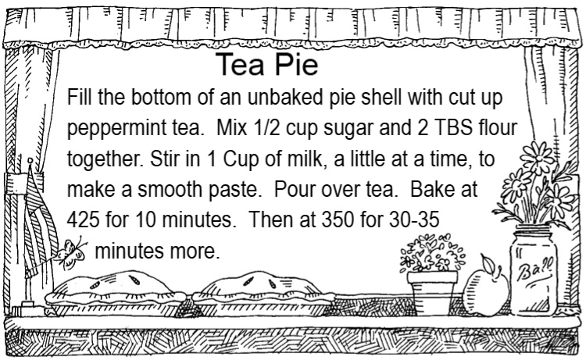

**MISSION OF THE MONTH**

**CEF**

For over 80 years God has been using **C**hild **E**vangelism **F**ellowship to bring the love of Jesus Christ to children around the world. The Word of God puts a high priority on children. They are near to God’s heart and He is uniquely concerned about their spiritual welfare.

CEF has over 3,500 missionaries internationally, approximately 3,400 of whom are nationals. There are 852 full-time workers across the USA and Canada, with the help of an estimated 40,000 volunteers. With workers in countries around the world, CEF ministered to more than 16.4 million children last year. CEF has a passion to not only bring children into a relationship with God, but to teach them His Word and lead them to churches so that they can become mature in their faith. In our society today, that is so important. Perhaps God is leading you to become more involved in the lives of children, for His kingdom’s sake. CEF will train, equip and encourage you as you follow that leading.

St. Andrew’s will be financially supporting CEF through our Mission of the Month for June. **We will welcome a young missionary, Christopher Hautle (Hot-Lee), to our Sunday morning worship service on June 23.** He will share with us his involvement with CEF and how the Lord is using him.

The Good News Day Camp for the Valley View Park will be held July 8-12, from 9:30 am to 3:00 pm, daily. For anyone interested in possibly helping with this camp, or for those kids interested in attending, there are Registration Forms in the Fellowship Hall.

**\*\*\*\*\*\*\*\*\*\*\*\*\*\*\*\*\*\*\*\*\*\*\*\*\*\*\*\*\*\***

**Peanut Butter Update**

The Harrisburg Supervisory Area collected a total of **6,000 jars of peanut butter** during Lent. WOW! Thank you to all for participating.



It's time to register for summer camps. Registration is now open online. Reminder to all that the church has funds generously provided to pay for anyone from St. Andrew's ministries who wants to attend (including youth group & Awana). There are programs for all ages. [https://suscrm.org](https://suscrm.org/)



**June 30th at 10:00 am**

Mark your calendars! We will worship our Lord and enjoy the beauty of nature at the Valley View Park. Worship will be at the stage (weather permitting).

Lunch will be at 11:30am at the Eating House. Meat, drinks, paper products, and utensils will be provided. Please sign up with the number attending and the category of your covered dish (side or dessert).

There will be games for children and adults after lunch. Come and enjoy fun, fellowship and of course, food!

There will be no Sunday School this day. Watch the bulletin for more information.



St. Andrew’s will be holding its **74th** **Annual** Father’s Day Breakfast at the

Valley View Park, June 16, 2024

5:00am – 7:00 am in the Eating House.

**Nursing Home – Assisted Living-**

**Group Homes – Rehab, (family)**

Ferne Furman – Rehab TBD

Randy Snyder

Vanessa Weaver

Rosewood Rehab. & Nursing Center

401 University Dr., Room 203C

Schuylkill Haven, PA 17972

**Josie Artz**

Schuylkill Manor

1000 Schuylkill Manor Road

Pottsville PA 17901

**Tillie Wolfgang**

Our thoughts and prayers for the family of:

Lois Bennick

Faye Kahler

Pastor Phil Sabas



**Major Jennifer Renninger**

512 American Legion, Pine Grove, Pa 17963



St. Andrew’s will be hosting a Blood Drive,

June 3rd, 1:00pm – 6:00pm. You can make an appointment to donate blood at [redcross.org](http://redcross.org/) or by calling 1-800-733-2767.

Pottsville Nursing & Rehab

420 Pulaski Drive

Pottsville, PA 17901

**Gail Bowman**

Providence Place, Pine Grove

24 Hikes Hollow Road

Pine Grove, PA 17963

**Ella Artz, Marilyn Herb**

Tremont Health & Rehab Center

44 Donaldson Road

Tremont PA 17981

**Jo Ann Shade, Roger Schwalm**

Mt. Carmel Nursing Rehab Center

2610 Locust Gap Highway

Mt. Carmel, PA 17851

**Jeannette Zerbe**

**Pastoral Sons**

**Chaplain Glenn R. Scheib**,

95-957 Wikao Street Mililani, HI 96789

**Rev. David Wagner**

7517 S. 950 W-92 North Manchester, Indiana 46962





| **June 2024** | | | | | | |
| --- | --- | --- | --- | --- | --- | --- |
| **Sun** | **Mon** | **Tue** | **Wed** | **Thu** | **Fri** | **Sat** |
| As a father has compassion on his children, so the Lord has compassion on those who fear him. Psalm 103:13 | | | | | | **1**  Annual Conference Ends  **Fellowship Hall Rental** |
| **2** | **3**  **1:00pm – 6:00pm – Blood Drive** | **4** | **5** | **6** | **7** | **8** |
| **9** | **10** | **11**  6:30pm – Trustees  7:30pm – Ad. Board | **12** | **13**  10:00am – Sr. Citizens | **14** | **15** |
| **16**  **Father’s Day** **Breakfast @ Valley View Park**  **5:00am – 7:00 am**  FATHERS DAY | **17** | **18**  1:00pm – UWIF | **19** | **20** | **21** | **22** |
| **23**  **6:00pm - VBS** | **24**  **6:00pm - VBS** | **25**  **6:00pm - VBS** | **26**  **6:00pm - VBS** | **27**  10:00am – Sr. Citizens  **6:00pm - VBS** | **28** | **29** |
| **30**  **\*10:00am –** **Worship/Picnic at the VV Park**  **No Sunday School** | **COME JOIN THE FUN & LEARN GOD’S LOVE AT VBS** | | | | | |

|  |
| --- |
| **Notes:****SUNDAY WORSHIP** – 9:00 am **SUNDAY SCHOOL** – 10:30 am **OFFICE HOURS** – Tuesday & Thursday – 10:00 am – 12:00 pm  **BULLETIN DEADLINE** – Thursday – 9:00 am  **NEWSLETTER DEADLINE** – Third Friday of Month  **\*** Watch bulletin for changes |





St. Andrew’s U.M. Church

PO Box 221

Valley View, PA 17983

*Address Service Requested

ST. ANDREW’S U.M. CHURCH

“S.A.M.”



**June 2024**