November 2023
St.
Andrew’s
Messenger

St. Andrew’s United Methodist Church “growing in passion for God, showing compassion to all”
Our Mission: “To make disciples of Jesus Christ, who are growing in passion for God and showing compassion to all, by sharing God’s REPAIRing Love.”
Our Vision:
making disciples through
Radical hospitality
Extravagant generosity
Passionate worship
Authentic witness
Intentional faith development
Risk taking mission

St. Andrew’s Web site: www.standrewsvalleyview.org

Pastor: Suzanne Elliott
570-682-3508 (office)
570-682-3520 (home)
e-mail: selliott@susumc.org

Fall is here and Thanksgiving will soon arrive. Our valley is so beautiful and so busy bringing in the harvest! I hope you take a moment or two to appreciate the beauty of God's Creation in all of its splendor. Let's also be thankful for the land which supplied our backyard gardens and our commercial growers. God is so good! I offer you this prayer for your devotions this month to help voice our common gratitude for God's abundant gifts.

Most gracious God, you crown the year with your goodness. We praise you that you have ever fulfilled your promise that, while earth remains, seedtime and harvest shall not cease. We bless you for the order and constancy of nature, for the beauty of earth and sky and sea, and for the providence that year by year supplies our need. We thank you for your blessing on the work of those who plowed the soil and sowed the seed, and have now gathered in the fruits of the earth. And with our thanksgiving for these blessings, accept our praise, O God, for the eternal riches of your grace in Christ our Lord; to whom, with you, O Father, and the Holy Spirit, be all glory and honor and worship, for ever and ever. Amen.
UM Book of Worship #418

Happy Thanksgiving!
~Pastor Suzanne

What’s Happening

November Missions of the Month

Thankoffering Meal

The United Women In Faith will be holding their annual Thankoffering Service and Dinner on Sunday, November 12th. Our speaker for the service will be Rev. Kevin Witt, Director Camp and Retreat Ministry.
Our Thankoffering Dinner will follow at 11:30 am. It will be eat in or take out. The meal is a choice of Ham with Mashed potatoes or Turkey with Filling, String Beans, bun and butter, drink and dessert. The cost will be $ 12.00 per platter. Tickets will be available beginning October from UWIF members.

Thanksgiving Meal

St. Andrew’s is hosting a FREE Thanksgiving Day Meal for any, and all, who would like to join us for a “full spread” meal. This will be our 7th year and we have been blessed each year to share this time with so many others! Your support and donations, each year, have enabled us to do this. Each year some person or family in need has been blessed because of gracious and generous monetary donations
received the day of the meal.
You are invited to come and share the day with family or friends, familiar and new.
We will serve from 11:30 am to 1:30 pm. There is no charge for the meal. We will serve eat-in or take-out meals. We only ask that you contact the church office at
(570) 682-3508 to register, for either eat-in or take-out. We would like to have a count by Sunday, November 19th. If you forget to register or your plans change, we welcome all walk-ins on Thanksgiving Day!
We will be needing help on Wednesday, the day before, for setting up the fellowship hall, as well as prepping food. On Thanksgiving Day, we will need help with cooking, serving, and clean-up. Pies, cakes, pumpkin rolls, or

cobblers will be needed, and perhaps some other meal items (Watch bulletins for any items needed).
We have been blessed with so much and what better way to share those blessings,
than to share a Thanksgiving Day Meal with those who may be feeling lonely,
missing family, or just those who want to enjoy the day out!
There will be a meeting on Tuesday, November 9th at 7:00 PM to go over details.
Donation / Volunteer sheets will be in the Fellowship Hall. If you are not able to
help during the meal hours but can help with clean up, you are more than welcome
to join us. If there are any questions, please contact Karen at 570-590-7330.

Pine Creek Outreach
Angel Tree

We are planning to participate again this year in the Pine Creek Outreach Ministry holiday collection. Watch the bulletin for further details.

Advent Season

Watch for next month's Newsletter for a full schedule of events for the Advent and Christmas season, starting December 3rd.

Worship for Sunday, December 24
9:00am - 4th Sunday of Advent
5:00pm - Christmas Eve Candlelight Service

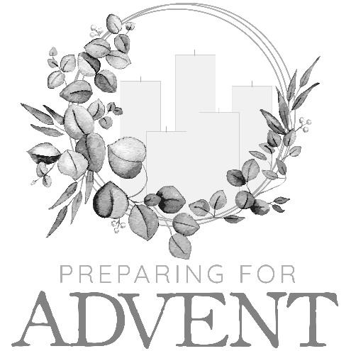

Church Conference

Our yearly Church Conference will be held on Tuesday, November 14 at 7:00 pm. Rev. Karen Atanasoff, Harrisburg District Assisting Elder, will preside. All church members are welcome to attend with a voice and vote.

Tri Valley Ministerium Thanksgiving Eve Service
Wednesday, November 22, 7:00 pm
Hepler’s Church of God, Pitman

All Saints Sunday
November 5, 2023

Each year on All Saints Sunday we remember those who have died in the previous year. The list could include church members, former pastors and spouses, or pastoral sons. If Pastor Suzanne has done the funeral or graveside for someone who does not have a church family, those persons are also included. We give thanks for each and every life and celebrate the hope and promise of life eternal.

Donald L. Morgan November 1, 2022
Donna (Richards) Bloch November 27, 2022
Irene K. Morgan December 2, 2022
Bruce D. Schwalm December 11, 2022
Don R. Deibler April 1, 2023
Alvin J. Schwartz April 9, 2023
Ellen Woodring July 14, 2023
Steve E. Deeter August 23, 2023

Office Hours and Information

Tuesday and Thursday 9:00 am - 11:00 am.
Secretary – Nolan Wiest
Note the office email address to use:
office@standrewsvalleyview.org

Newsletter Articles
E-mail to the address below:
office@standrewsvalleyview.org

Prayer Chain Contact
Carole Hepler (570) 682-3301
chelper@comcast.net

Upper Room Devotional
The Upper Room provides a daily devotional for you to read. It includes a Bible text, memory verse, inspirational reading, thought for the day, and a closing prayer. The prayer focus for that day is listed at the end. Start each day with time for the Lord.
The books are available at the entrance doors.

Pastoral Sons
Chaplain Glenn R. Scheib,
95-957 Wikao Street Mililani, HI 96789
Rev. David Wagner
7517 S. 950 W-92 North Manchester, Indiana 46962

Our Military

Major Jennifer Renninger
512 American Legion, Pine Grove, Pa 17963

Nursing Home – Assisted Living – Group Homes – Rehab, (family)

Danville: Vanessa Weaver

Polk Personal Care Center
301 North Street, Millersburg, PA 17061
Roberta Huntsinger

Pottsville Nursing & Rehab
420 Pulaski Drive
Pottsville, PA 17901
Gail Bowman

Providence Place, Pine Grove
24 Hikes Hollow Road,
Pine Grove, PA 17963
Ella Artz, Marilyn Herb, Dorothy Snell

Rosewood Rehab. & Nursing Center
401 University Dr., Room 203C
Schuylkill Haven, PA 17972
Josie Artz

Schuylkill Manor
1000 Schuylkill Manor Road
Pottsville PA 17901
Tillie Wolfgang

Tremont Health & Rehab Center
44 Donaldson Road
Tremont PA 17981
Roger Schwalm, Jo Ann Shade

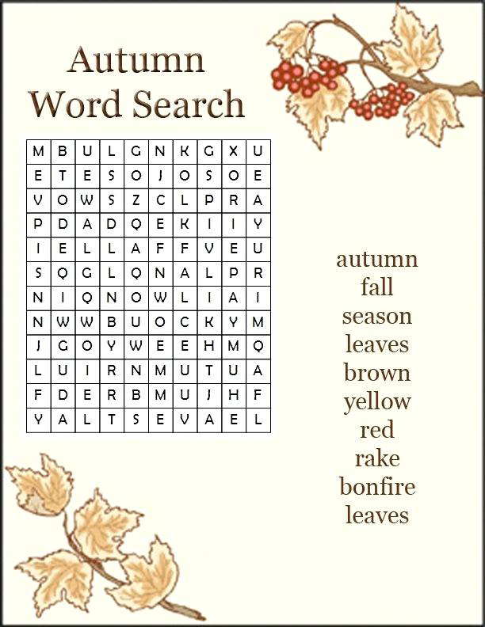

2022

Sunday | Monday | Tuesday | Wednesday | Thursday | Friday | Saturday
29 | 30 | 31 | 1 | 2 | 3 | 4
 |  |  | 6:00pm – AWANA | 9:00am –  Bulletin Deadline  9:00-11:00am-  Office Hours  10:00am –
5 | 6 | 7 | 8 | 9 | 10 | 11
9:00am –  All Saints Sunday,  Worship  10:30am – Sunday School | 6:15pm –  Men’s Chorus  7:00pm –  Chancel Choir  7:30 –  Cantata Choir | 9:00am –  Office Hours | 6:00pm – AWANA | 9:00am –  Bulletin Deadline  9:00-11:00am-  Office Hours  10:00 am –  Sr. Citizens |  | Veterans Day
12 | 13 | 14 | 15 | 16 | 17 | 18
9:00am – Worship  10:30am – Sunday School  Thankoffering Sunday | 6:15pm –  Men’s Chorus  7:30 –  Cantata Choir | 9:00am –  Office Hours  6:30pm –  Trustees Meeting  7:00pm –  Church Conference | 6:00pm – AWANA | 9:00am –  Bulletin Deadline  9:00-11:00am-  Office Hours | S.A.M Newsletter Deadline
19 | 20 | 21 | 22 | 23 | 24 | 25
9:00am – Worship  10:30am – Sunday School | 6:15pm –  Men’s Chorus  7:00pm –  Chancel Choir  7:30 –  Cantata Choir | 9:00am –  Office Hours  1:00pm –  UWIF | No AWANA | Thanksgiving Day  11:30–1:30pm –  Thanksgiving Meal
26 | 27 | 28 | 29 | 30 | 1 | 2
9:00am – Worship  10:30am-  Sunday School | 6:15pm –  Men’s Chorus  7:00pm –  Chancel Choir  7:30 –  Cantata Choir | 9:00am –  Office Hours | 6:00pm – AWANA | 9:00am –  Bulletin Deadline  9:00-11:00am-  Office Hours

November Missions of the Month
Thanksgiving meal, Thankoffering, and Pine Creek Angel Tree

St. Andrew’s U.M. Church
PO Box 221
Valley View, PA 17983

*address service requested

ST. ANDREW’S U.M. CHURCH
“S.A.M.”

November 2023

